Progress Report

Items used: Photoshop, HTML5, CSS3, JavaScript, Bootstrap, Flickr API

**Github Setup**

Signed up to Github and made a public account on Sunny95DMU with the repository CTEC3905_Web_Development_Assignment.

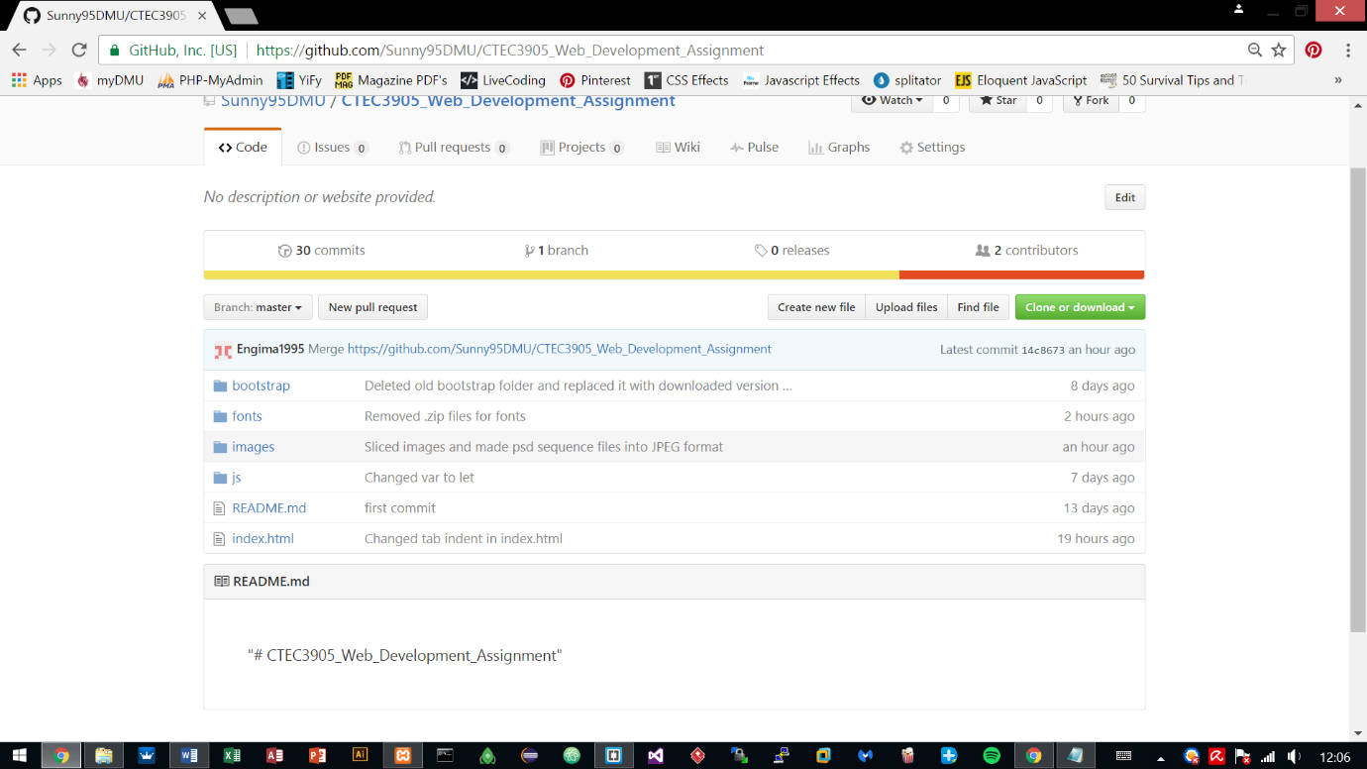

Installed .git local repository for pulling and pushing local work on to the Github repository.

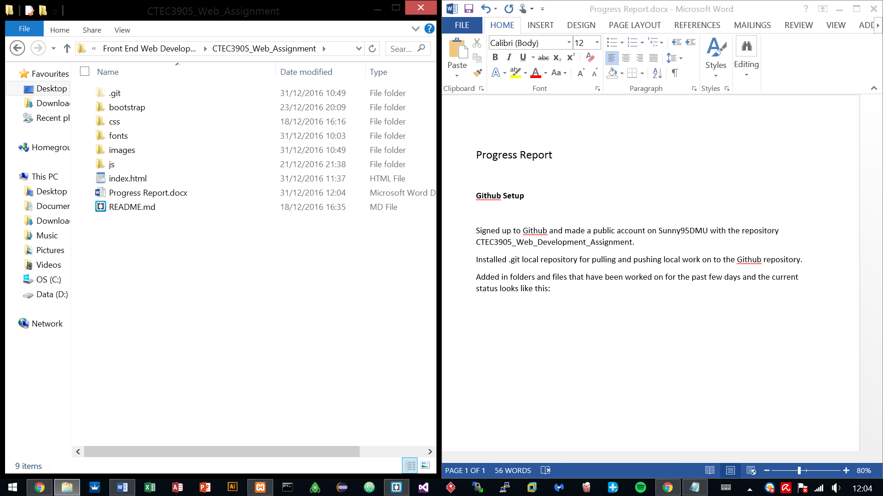Added in folders and files that have been worked on for the past few days and the current status looks like this:

**Fetching Flickr data with JSON**

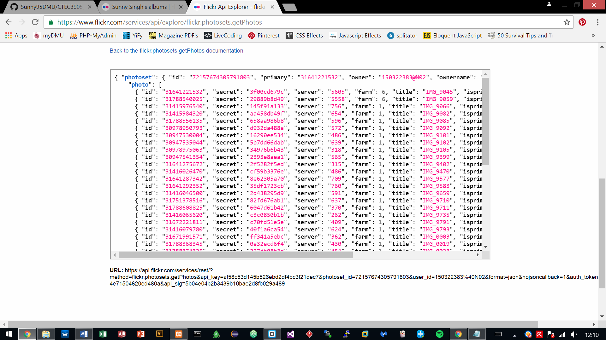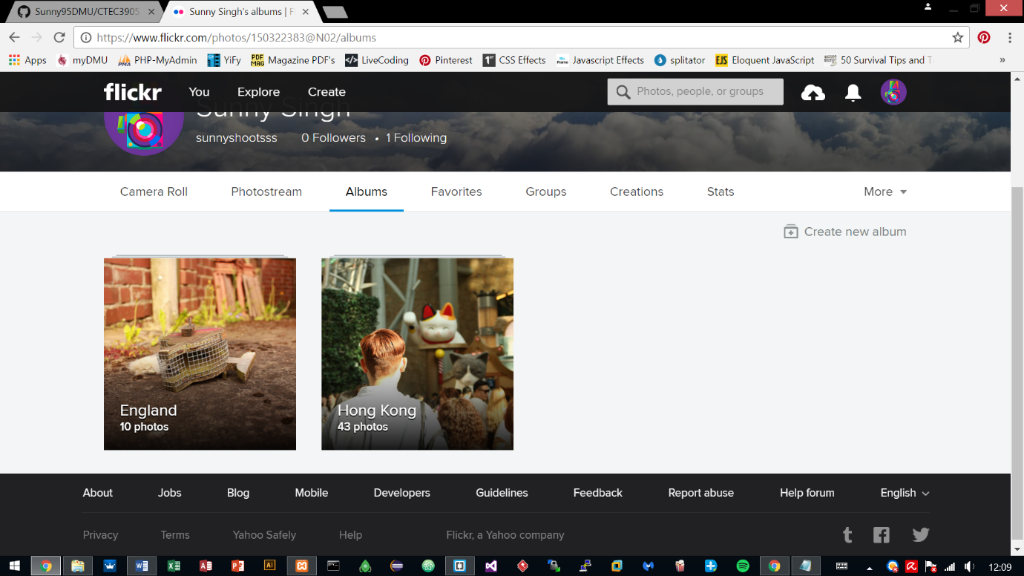Uploaded images to Flickr and used Flickr API to retrieve those uploaded images via JSON, for future use with the development of the site.

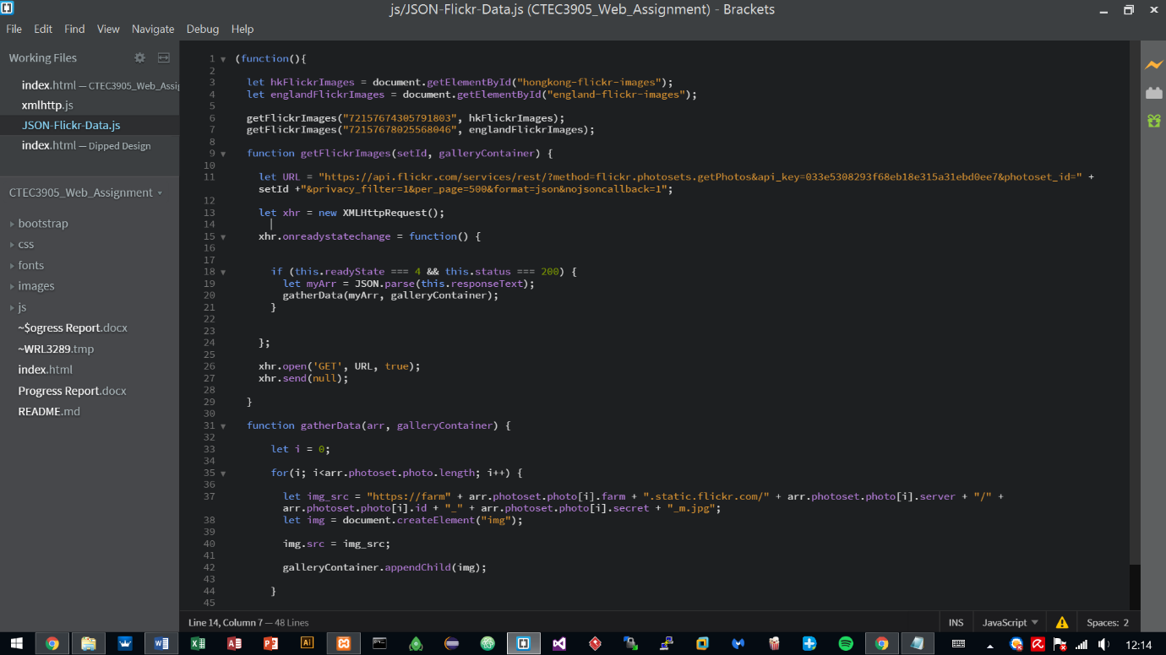Used the API key provided by the Flickr site and used it with JSON for connecting to the server, which in return gave an array of the uploaded images.

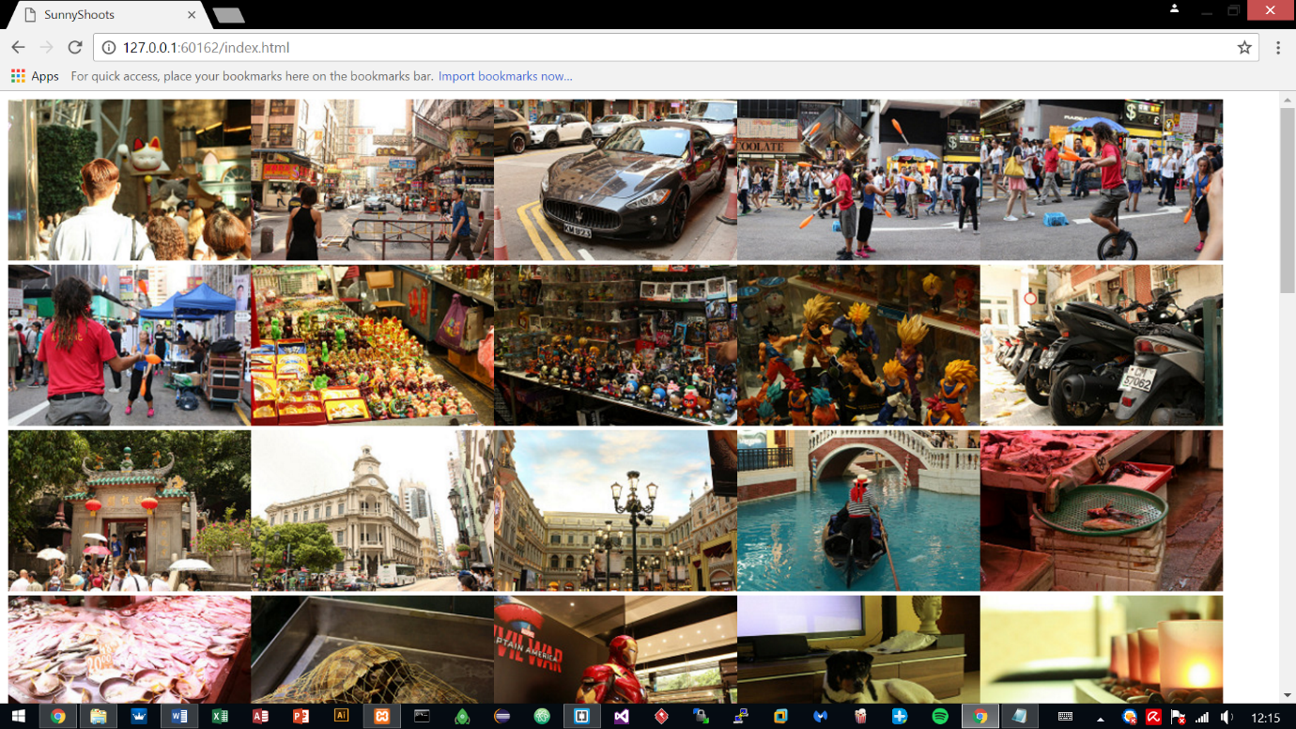

**Created Interface design**

After testing the JSON and the result being successful, it was time to move on to the interface design.

The website is based on a photography portfolio hence why testing the images was important.

The website was done in Photoshop and took 2 days to finish the interface, altogether 8 hours were put into it.

**Sequence 1 – Index Page**

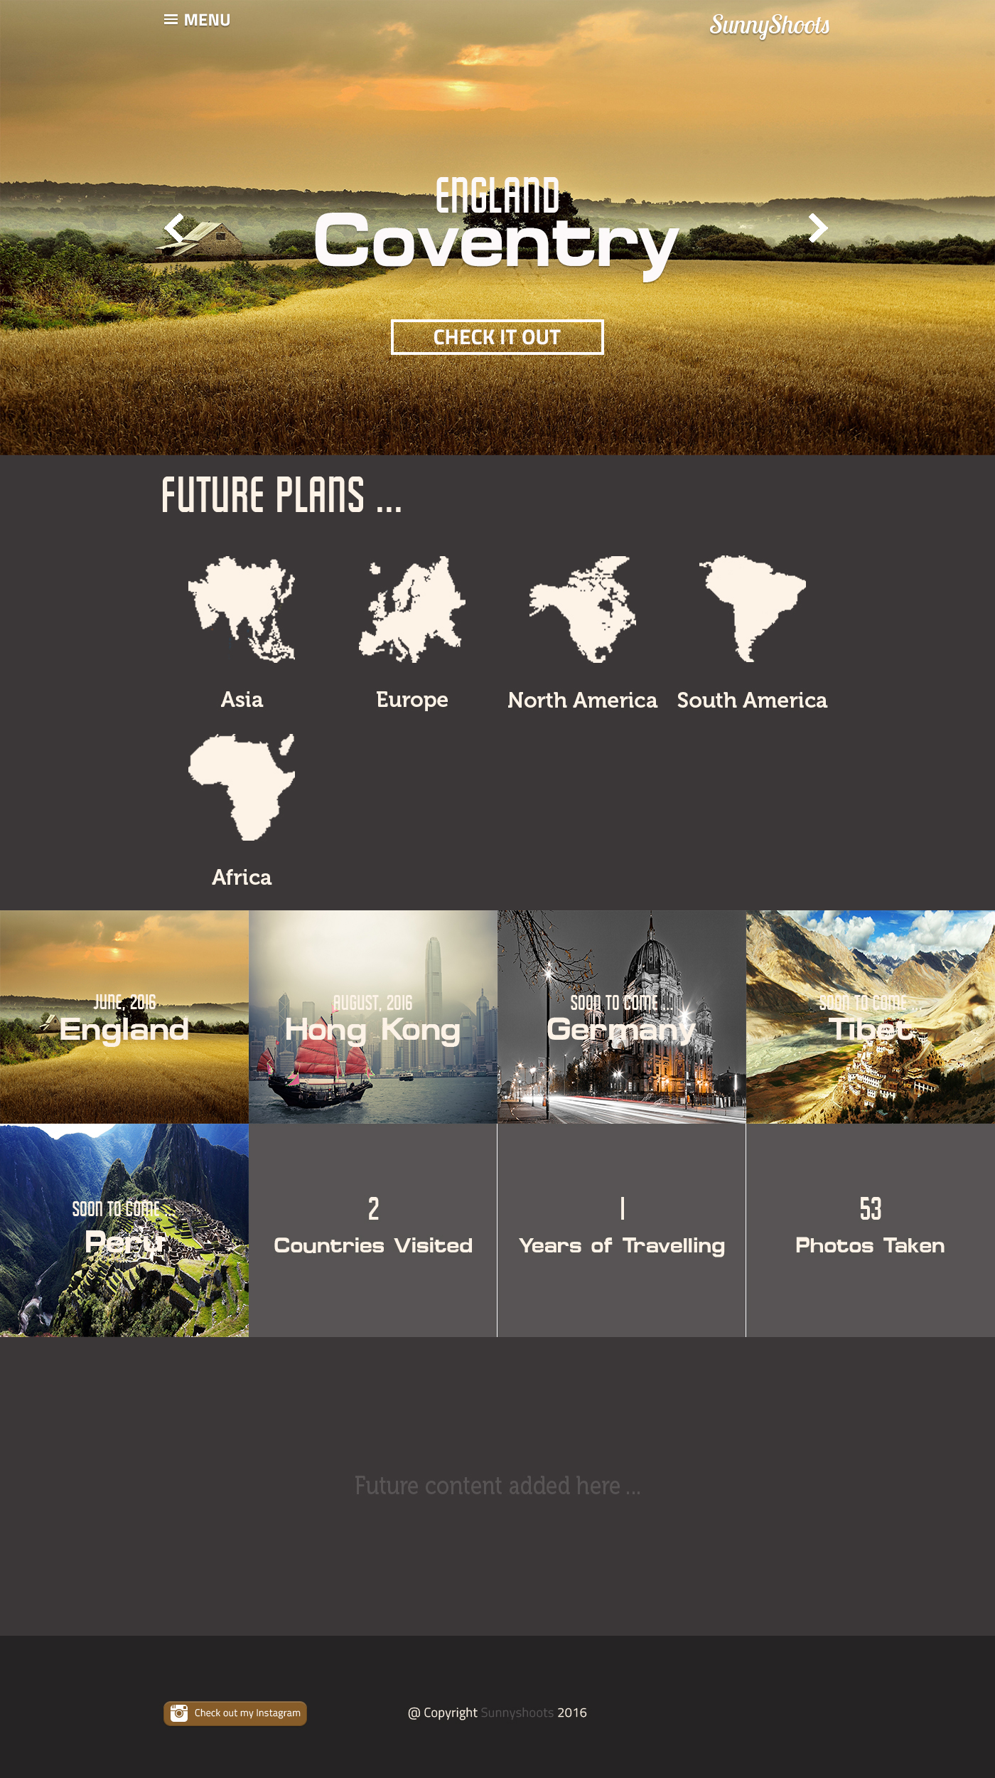

**Sequence 2 – Opening Menu**

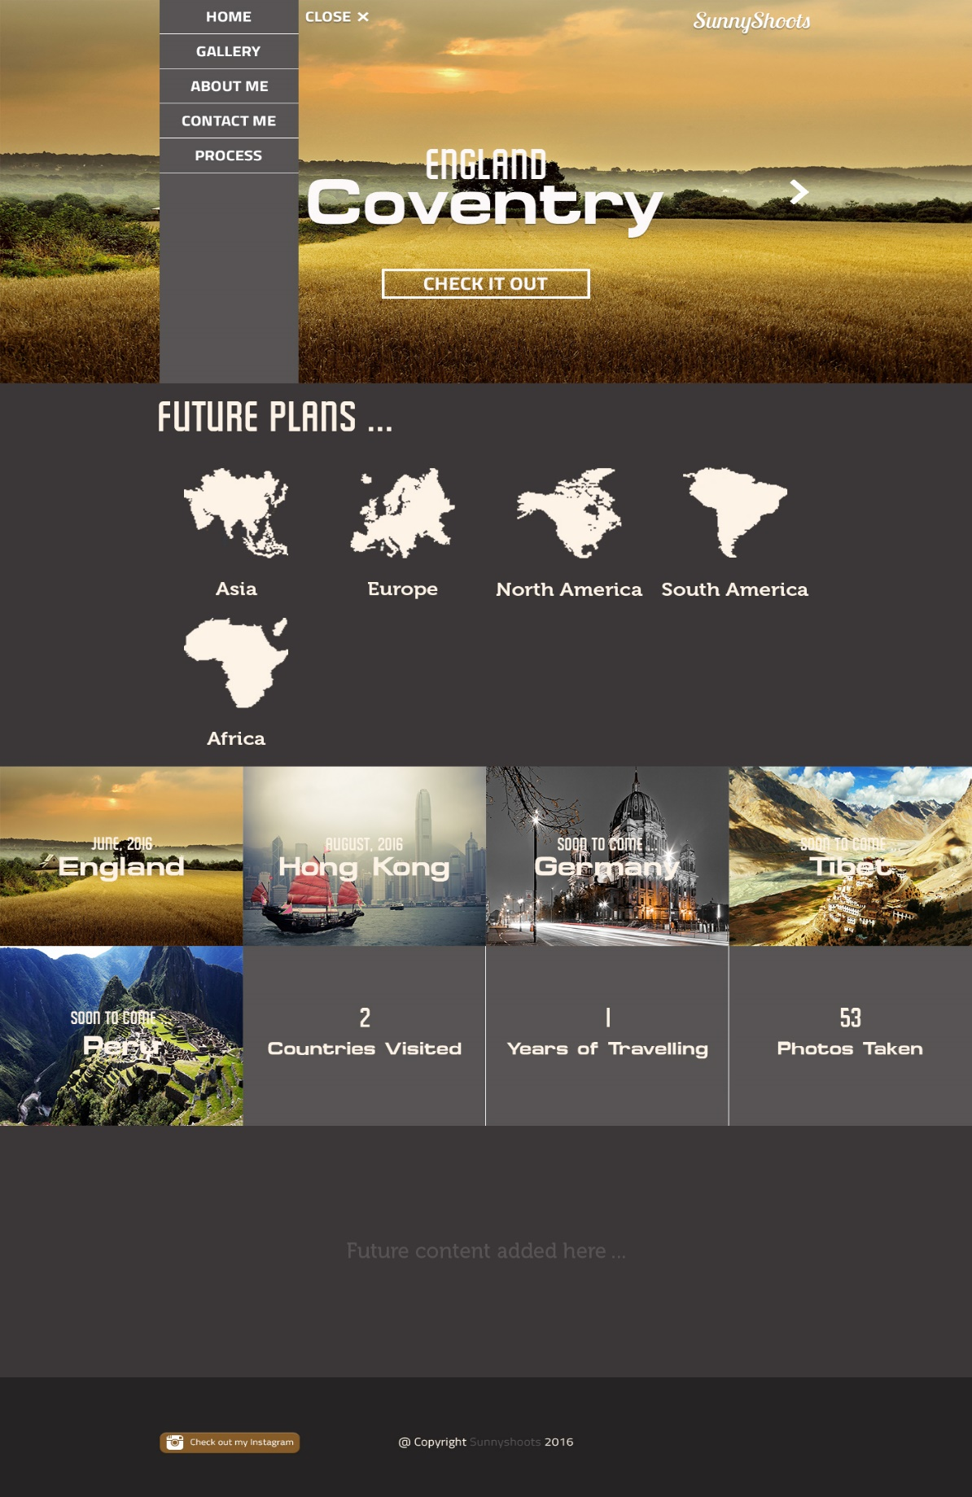

**Sequence 3 – Gallery Tab**

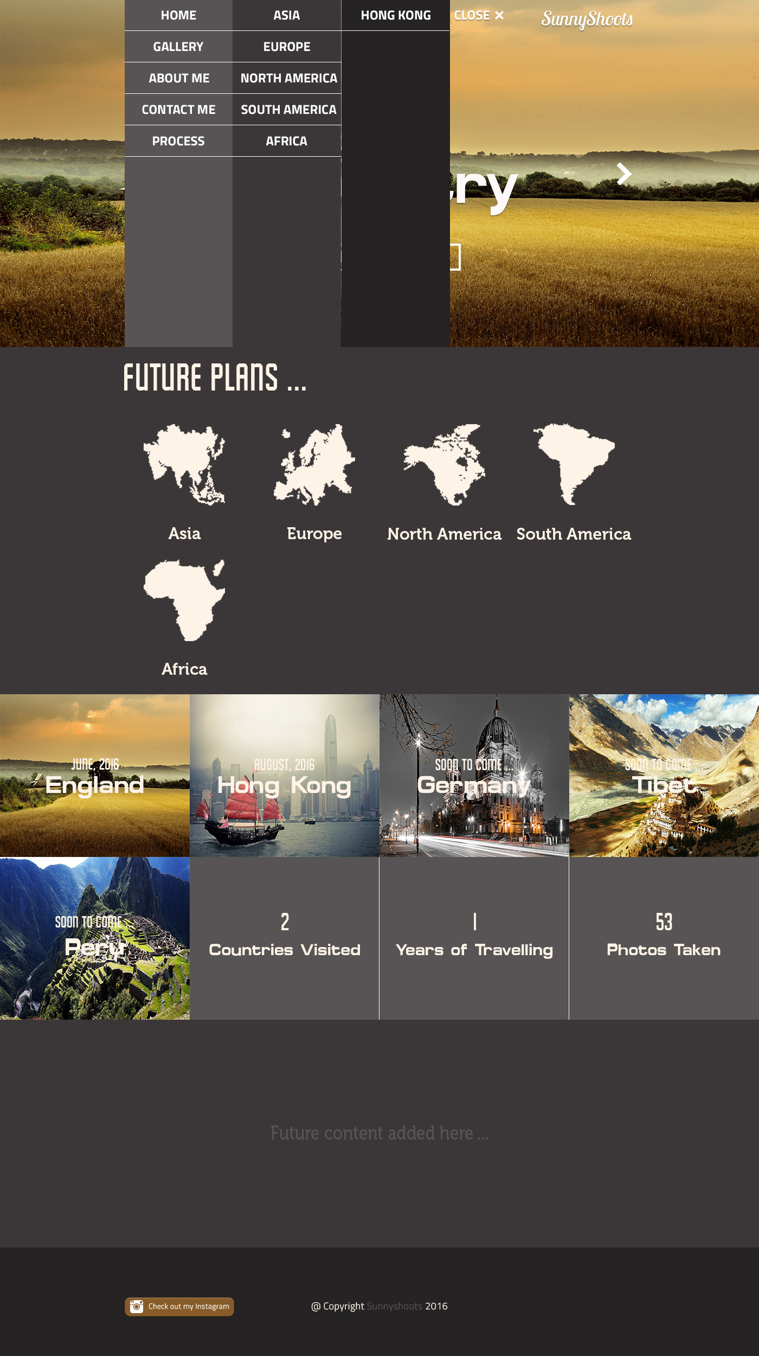

**Sequence 4 – Gallery Page**

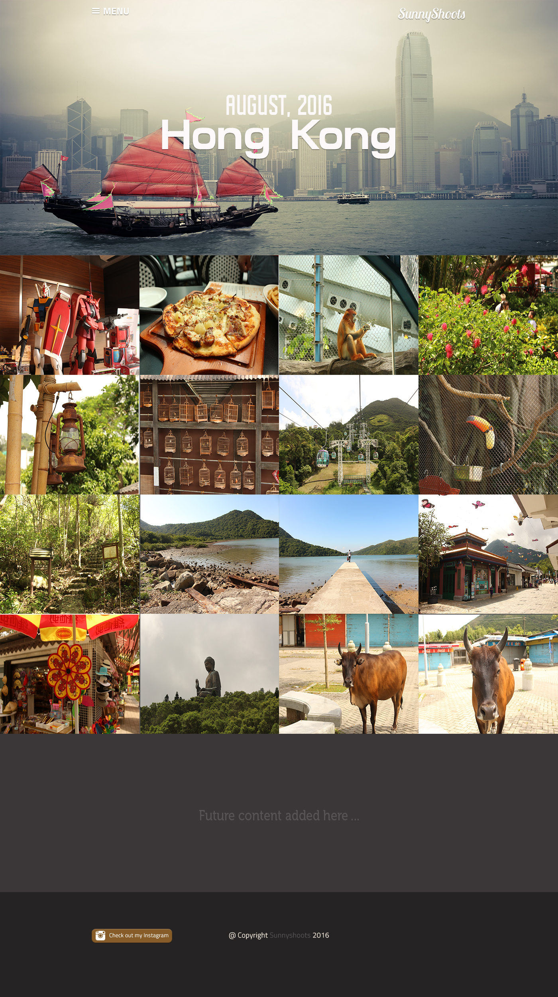

**Sequence 5 – About Me**

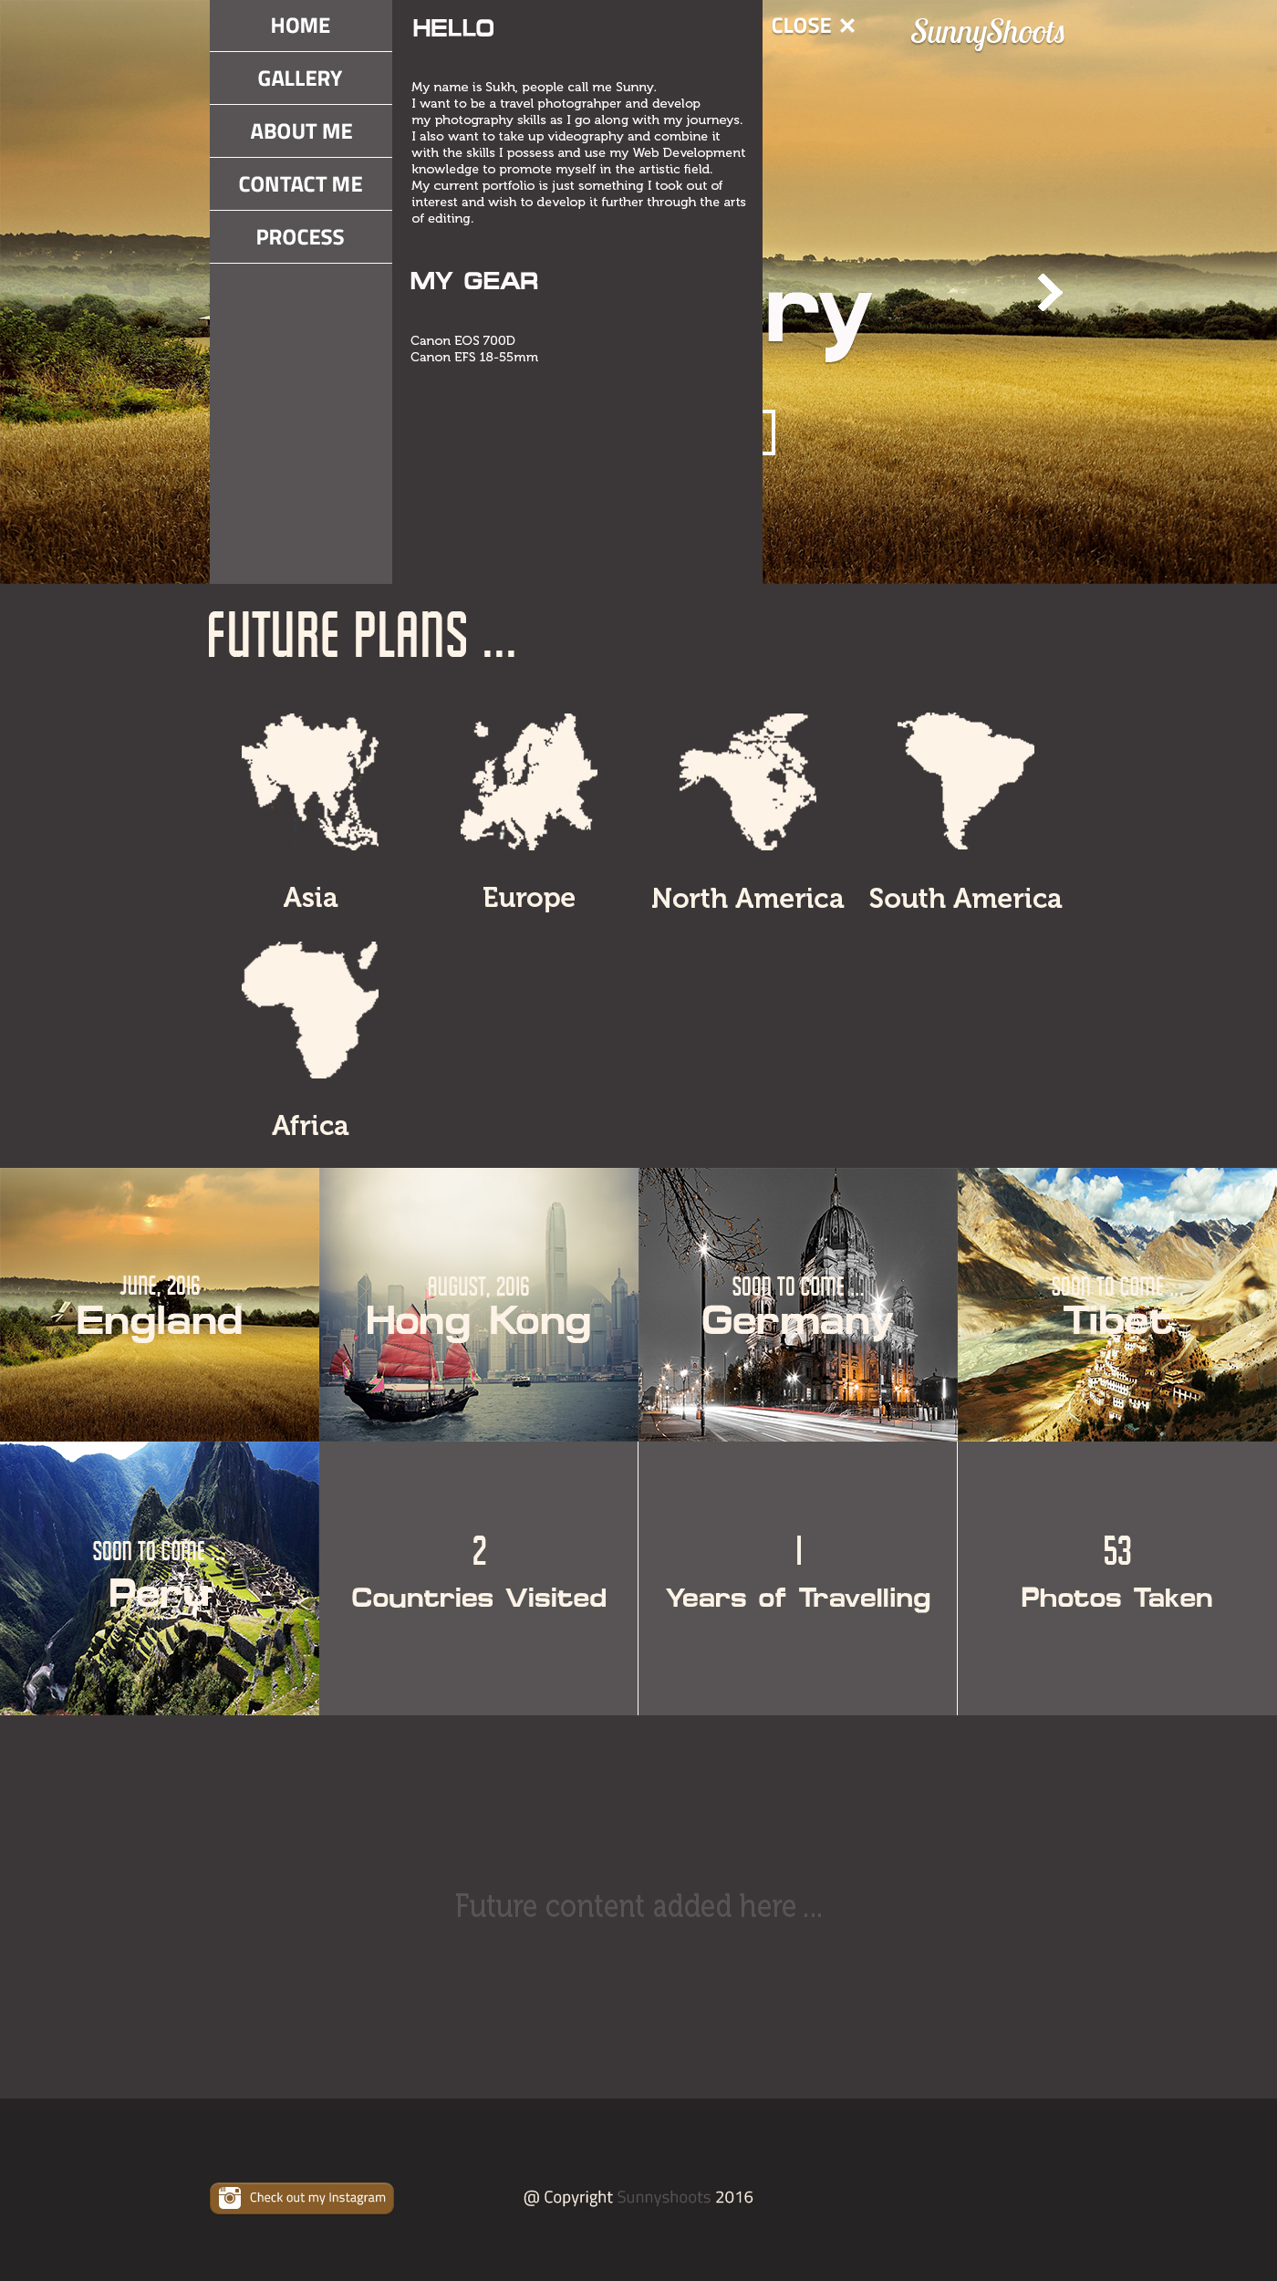

**Sequence 6 – Contact Me**

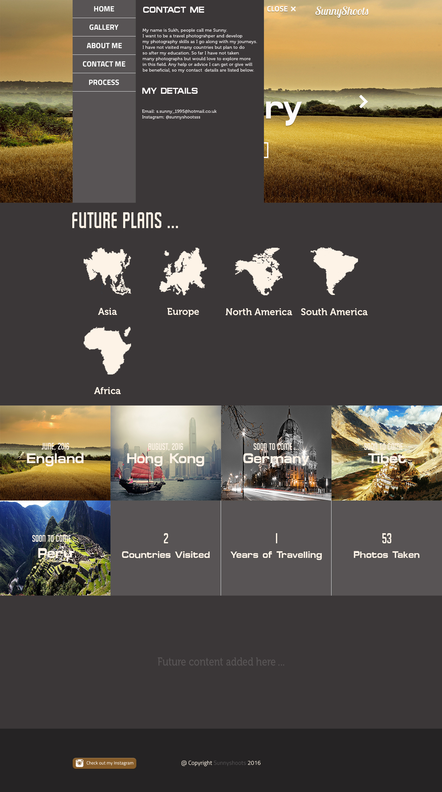

**Started working on index.html**

Index.html is the page that is loaded first. Most likely there are only going to be 3 pages altogether for this demo site: Home page and the Gallery Pages.

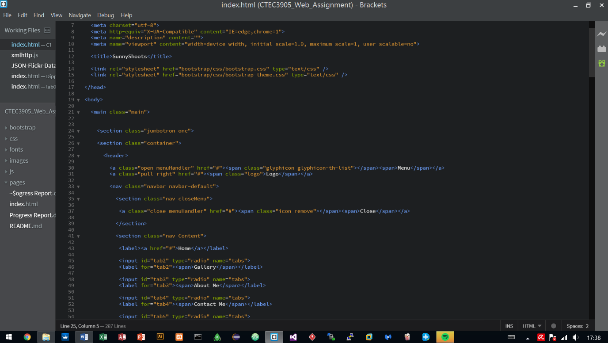Currently started structuring the index.html page using Bootstrap a quick framework to develop the site. The reason for this is, Bootstrap has been utilised before in other projects and has proven to work well as well as providing quick results so other areas could be looked at earlier on such as using animations and JavaScript to handle parts of the site.

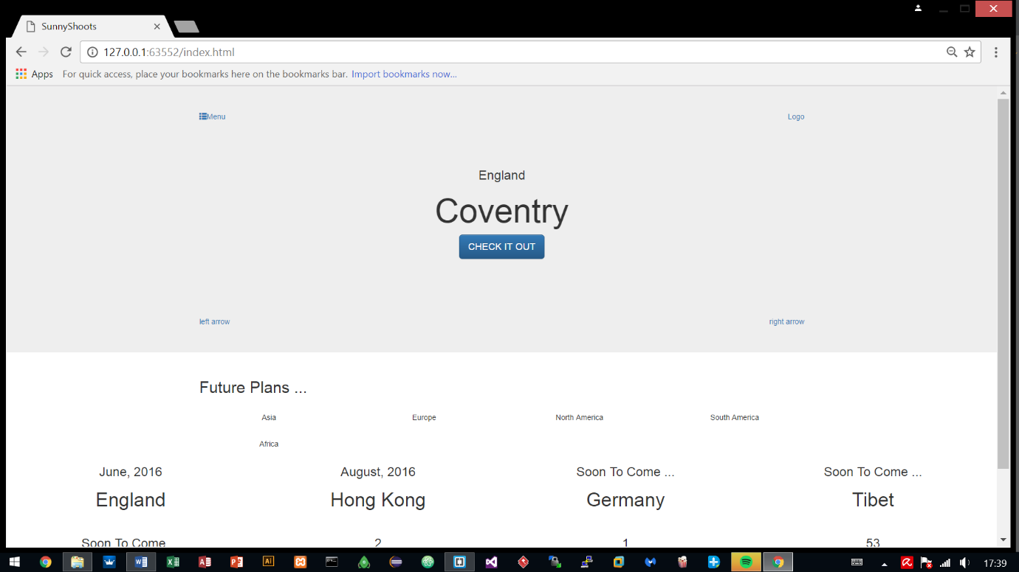

**Added two more pages – hongkong.html and england.html**

After working on the index.html, two more pages were added which are the gallery pages, displaying photographs of the places that were visited and the pages are titled according to the countries/cities visited.

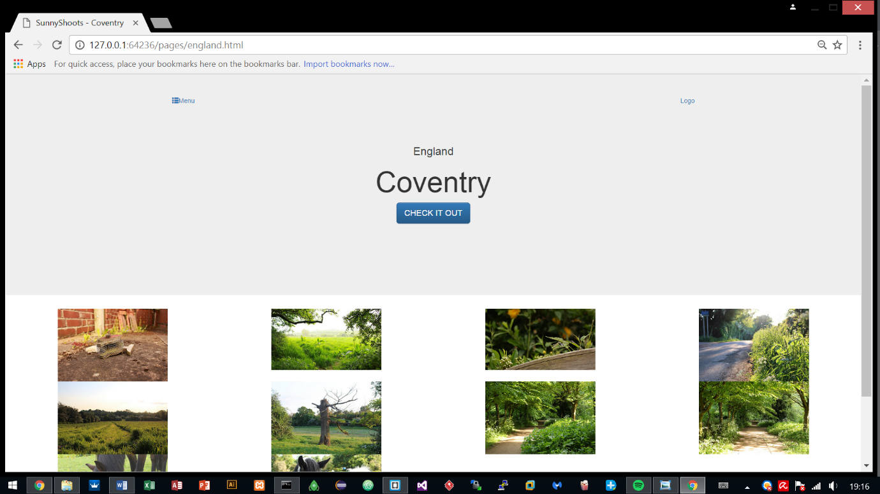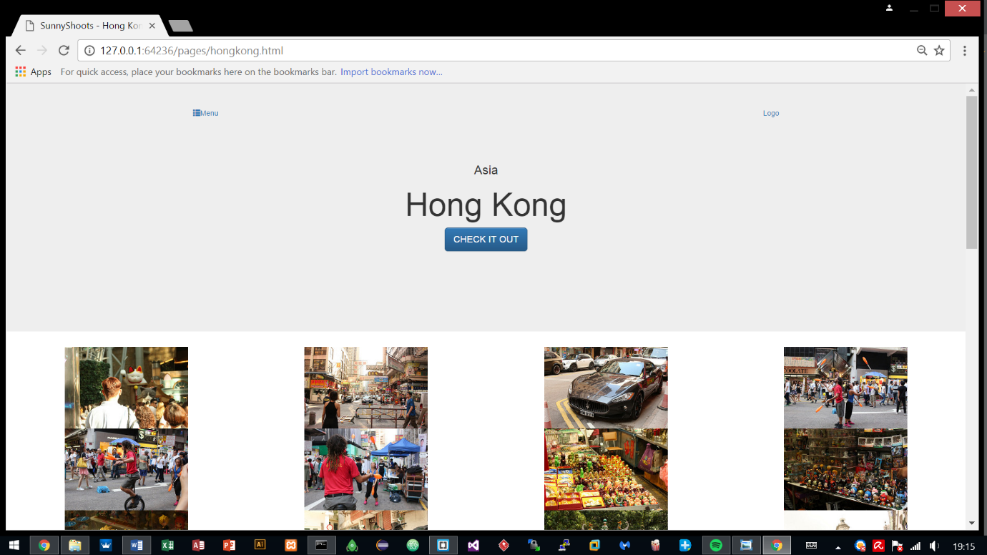The syntax for both pages have a similar layout compared with the index.html so most of it was just copied towards these html files and was edited. The two pages share the exact same syntax, only required changing of the class names.

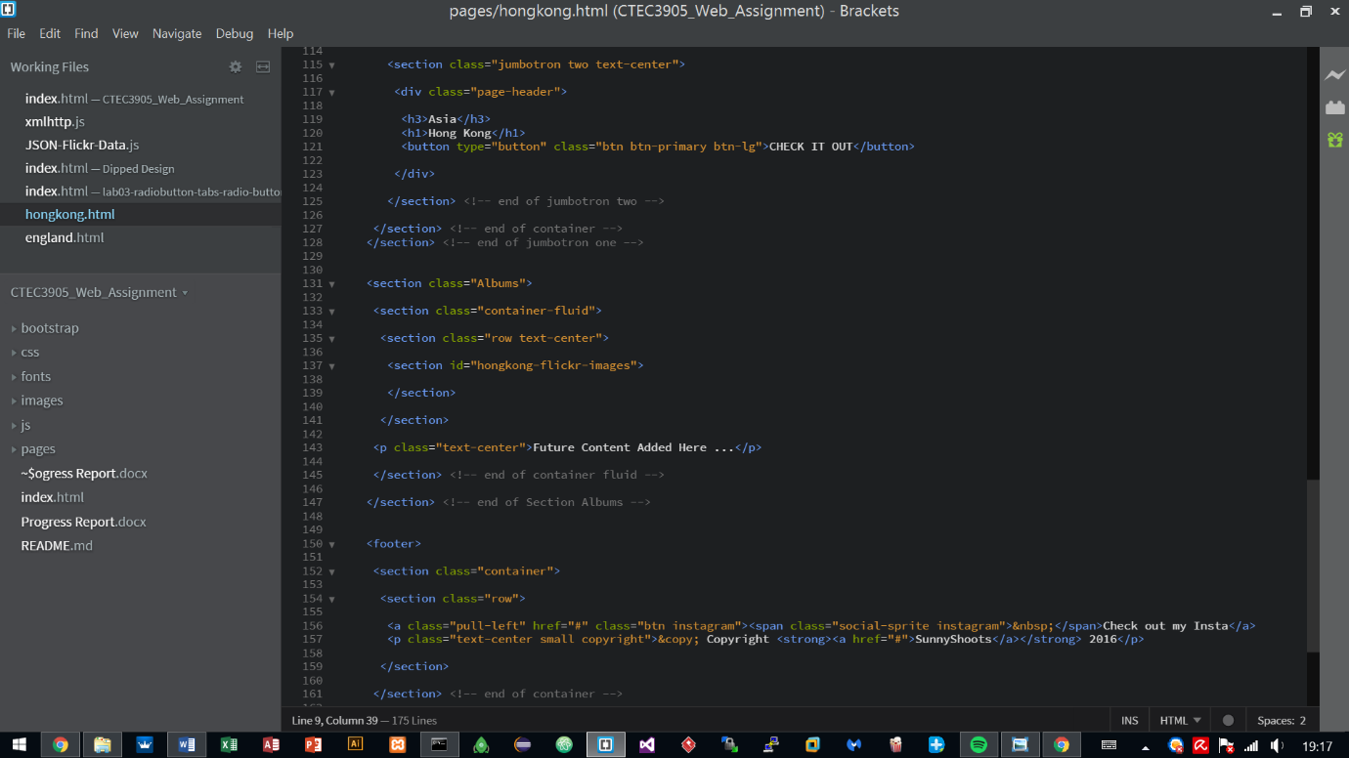

**Current Progress – Styling**

Styling has been started and has been done on the 1st and 2nd parts, other parts are still in progress.

The fonts and logos have been initialised to what the interface designs show and currently just working on finishing the styling so later on it can be using some interactive features using animations and Javascript.

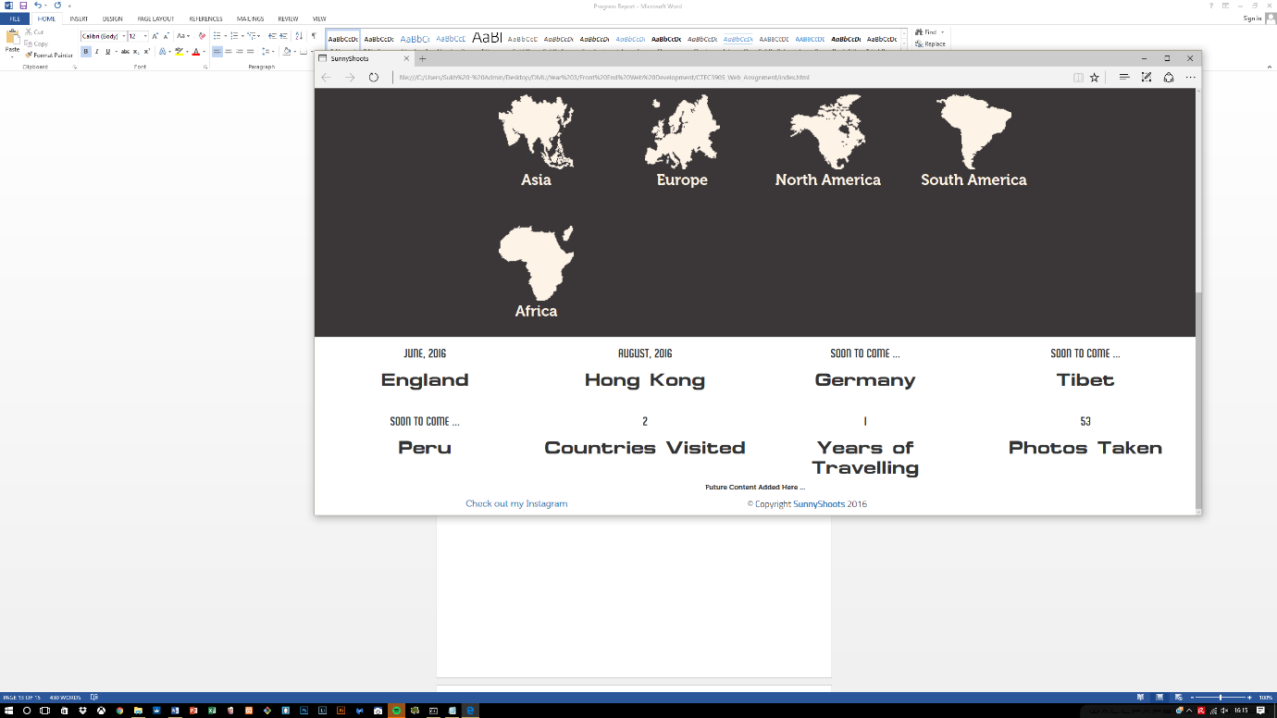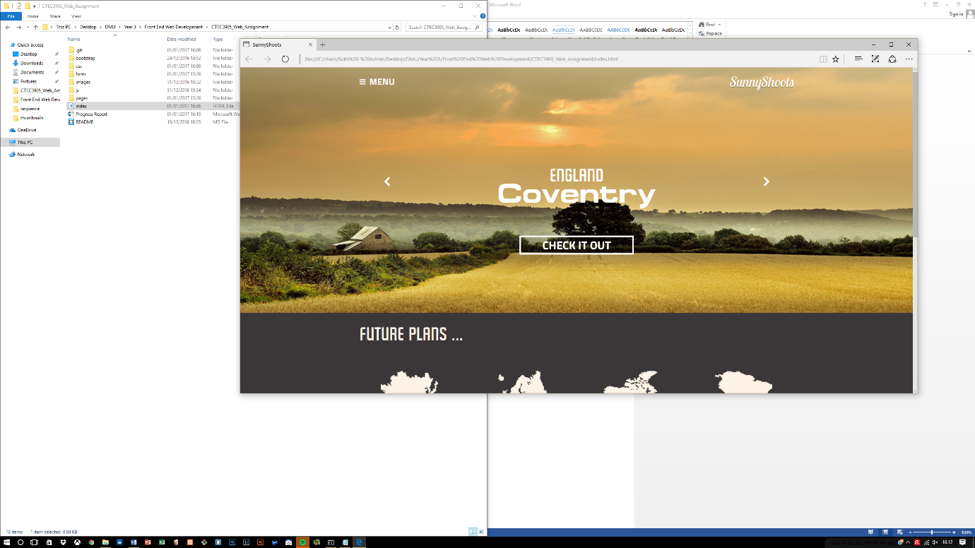

Two CSS stylesheets are being utilized that have been created by me, the rest is what Bootstrap provides by default.

Font.css sets up the font families that can be utilized within the development of the site and the style.css works by changing what bootstrap provides to suit to the interface design.

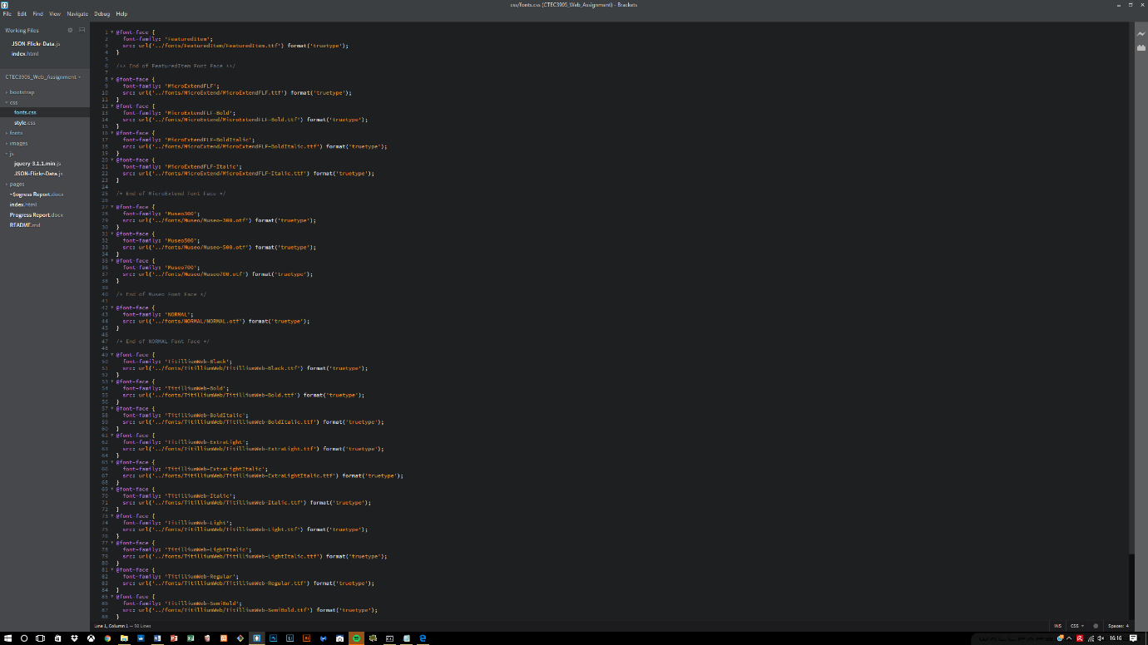

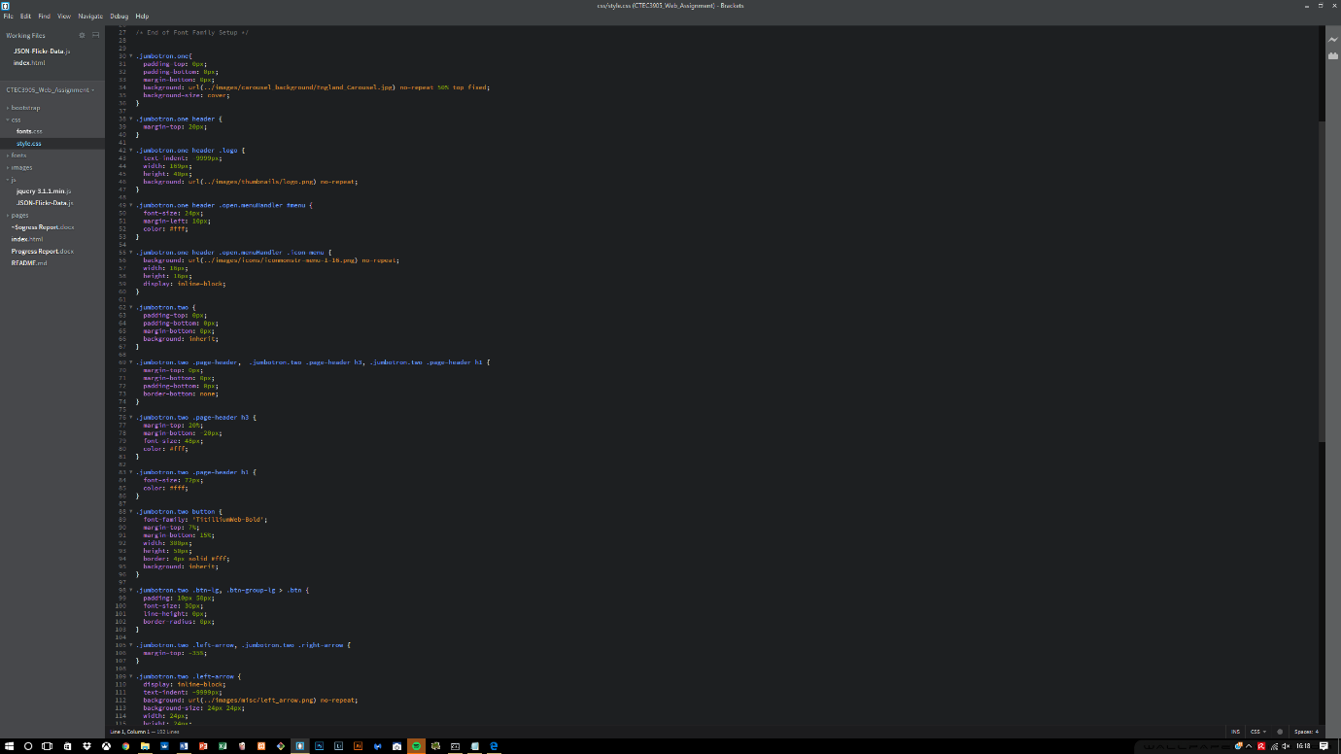

**Errors encountered within the first section**

Whilst developing, I soon realised that the structure of the semantics was not correct. The menu header was inside a container which held other main containers which should not have been there.

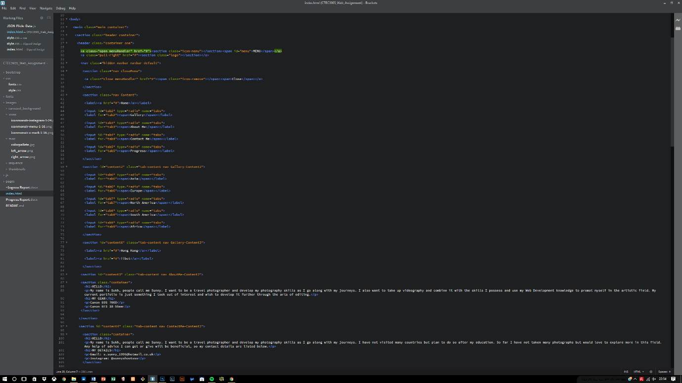Therefore the entire process took a lot of time due to rearranging of the structure and now the structure is working fine, the menu header is fixed and separated from the other content within the container. There is now the main container holding the entire site, and different containers holding relevant content.

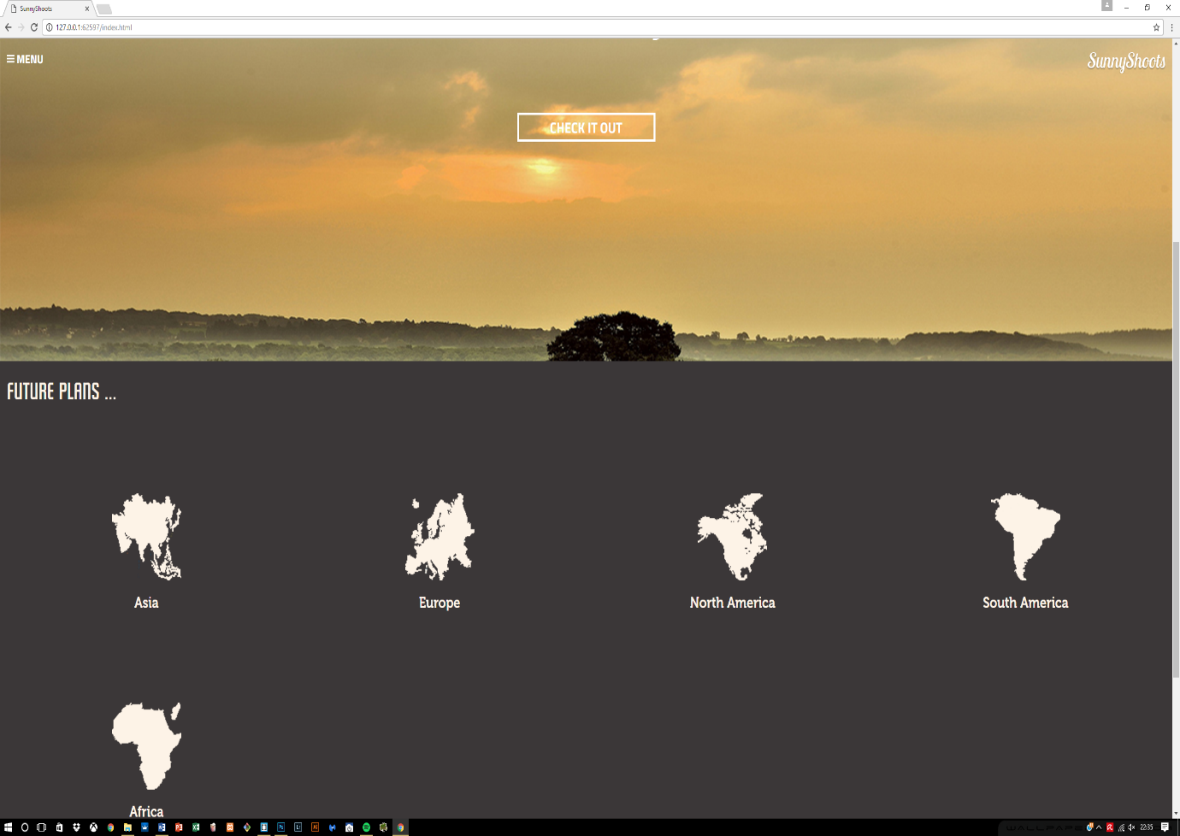

**Progress made after the errors**

After the first encounter with the errors, it was daunting to correct the mistakes and making sure the structure is correct which took up a lot of valuable time but on the contrary, the design aspect has finally come to an end. The website is developed according to the interface and all the pages show the correct results.

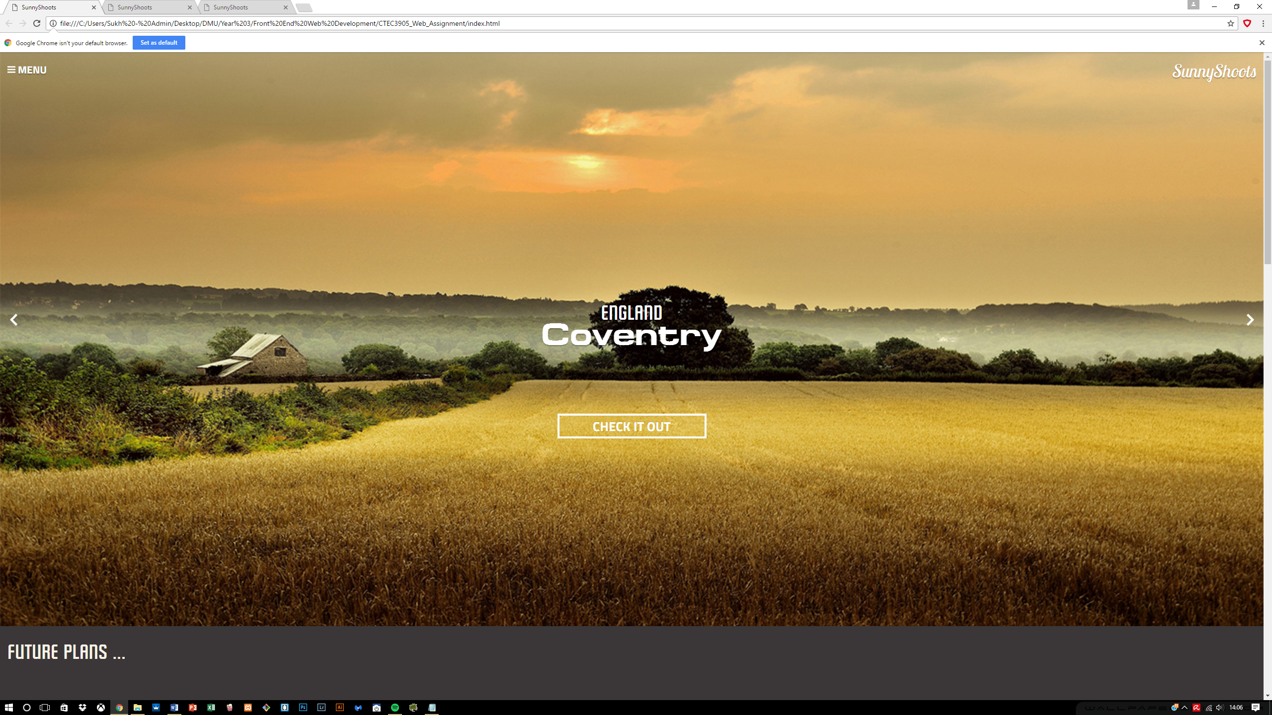

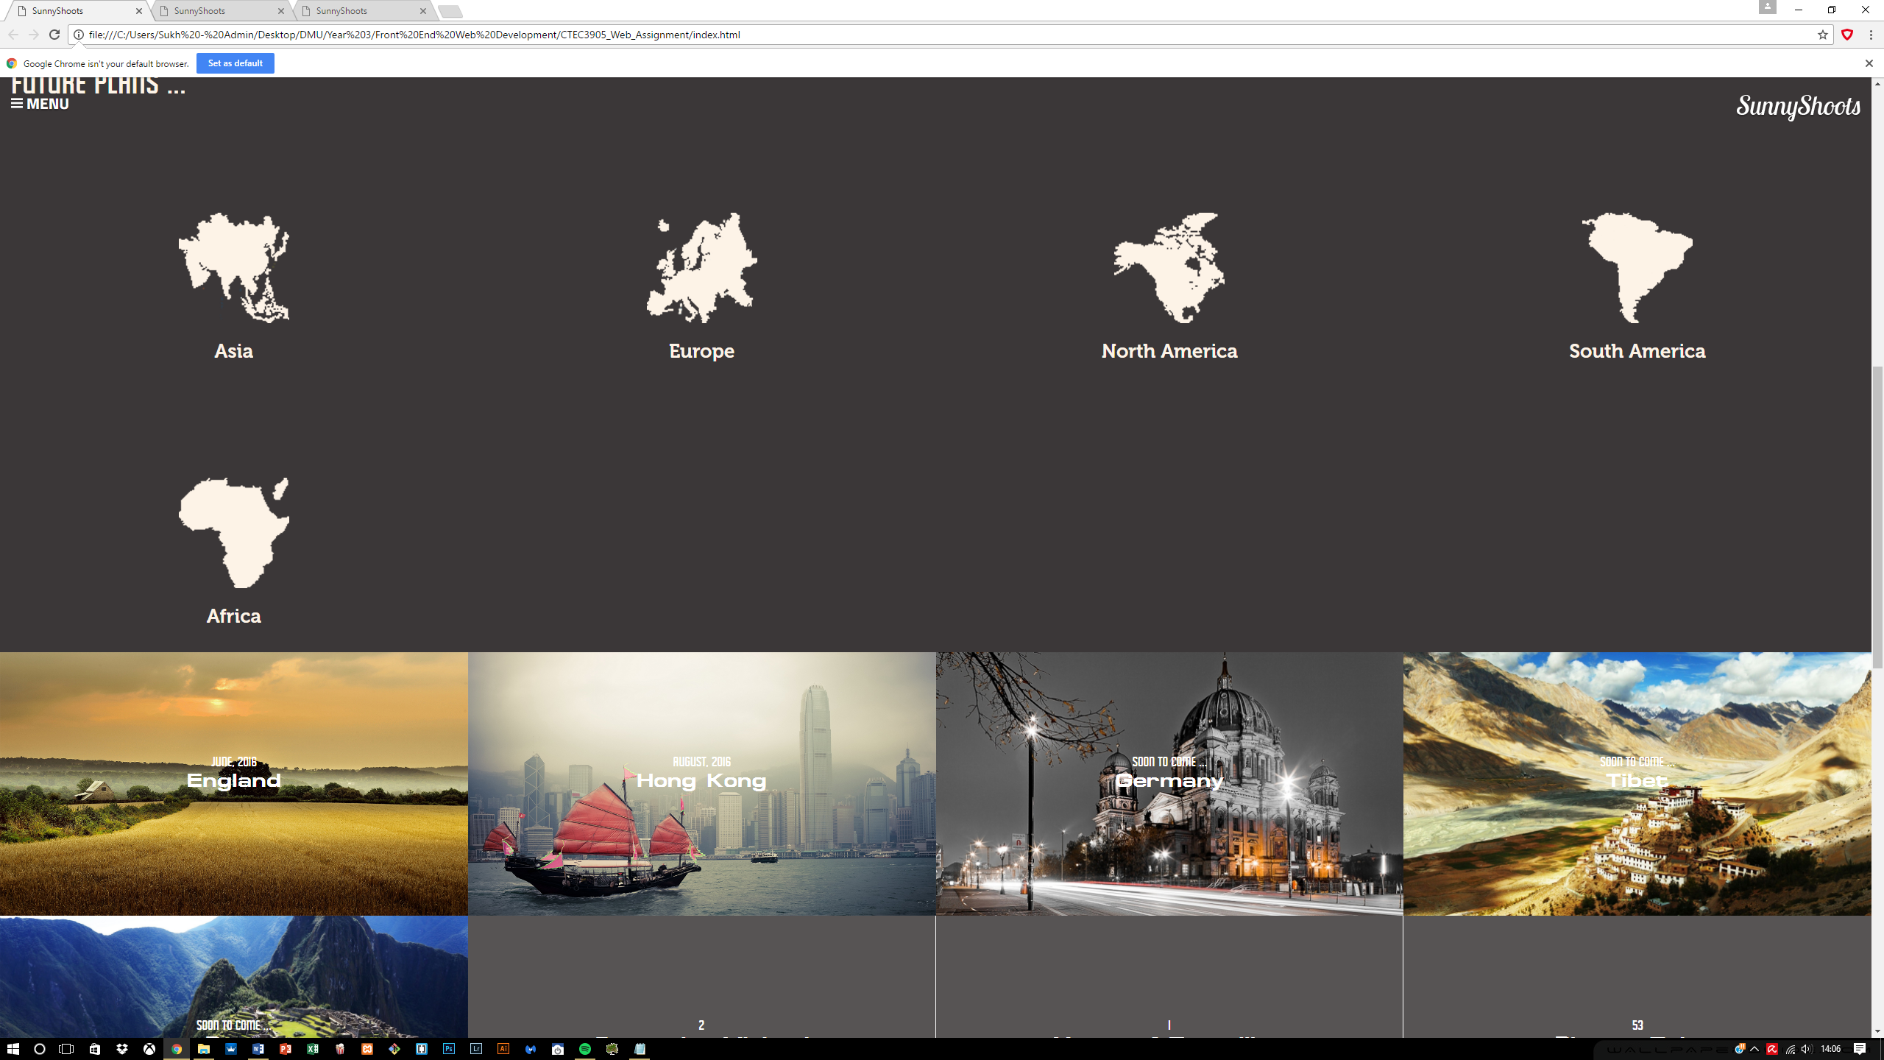

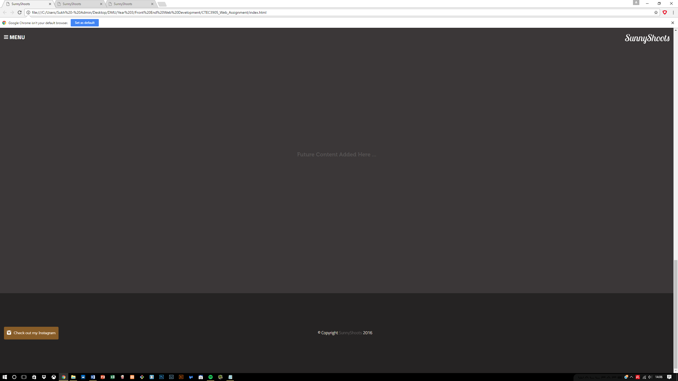

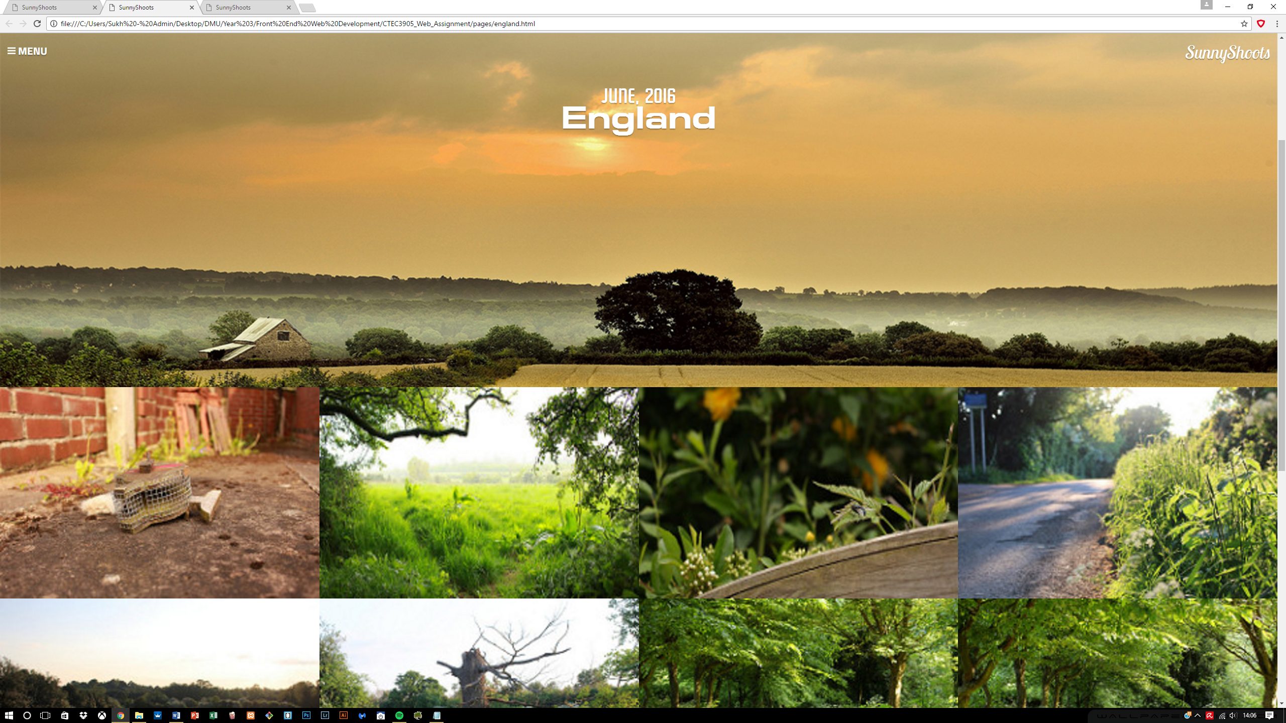

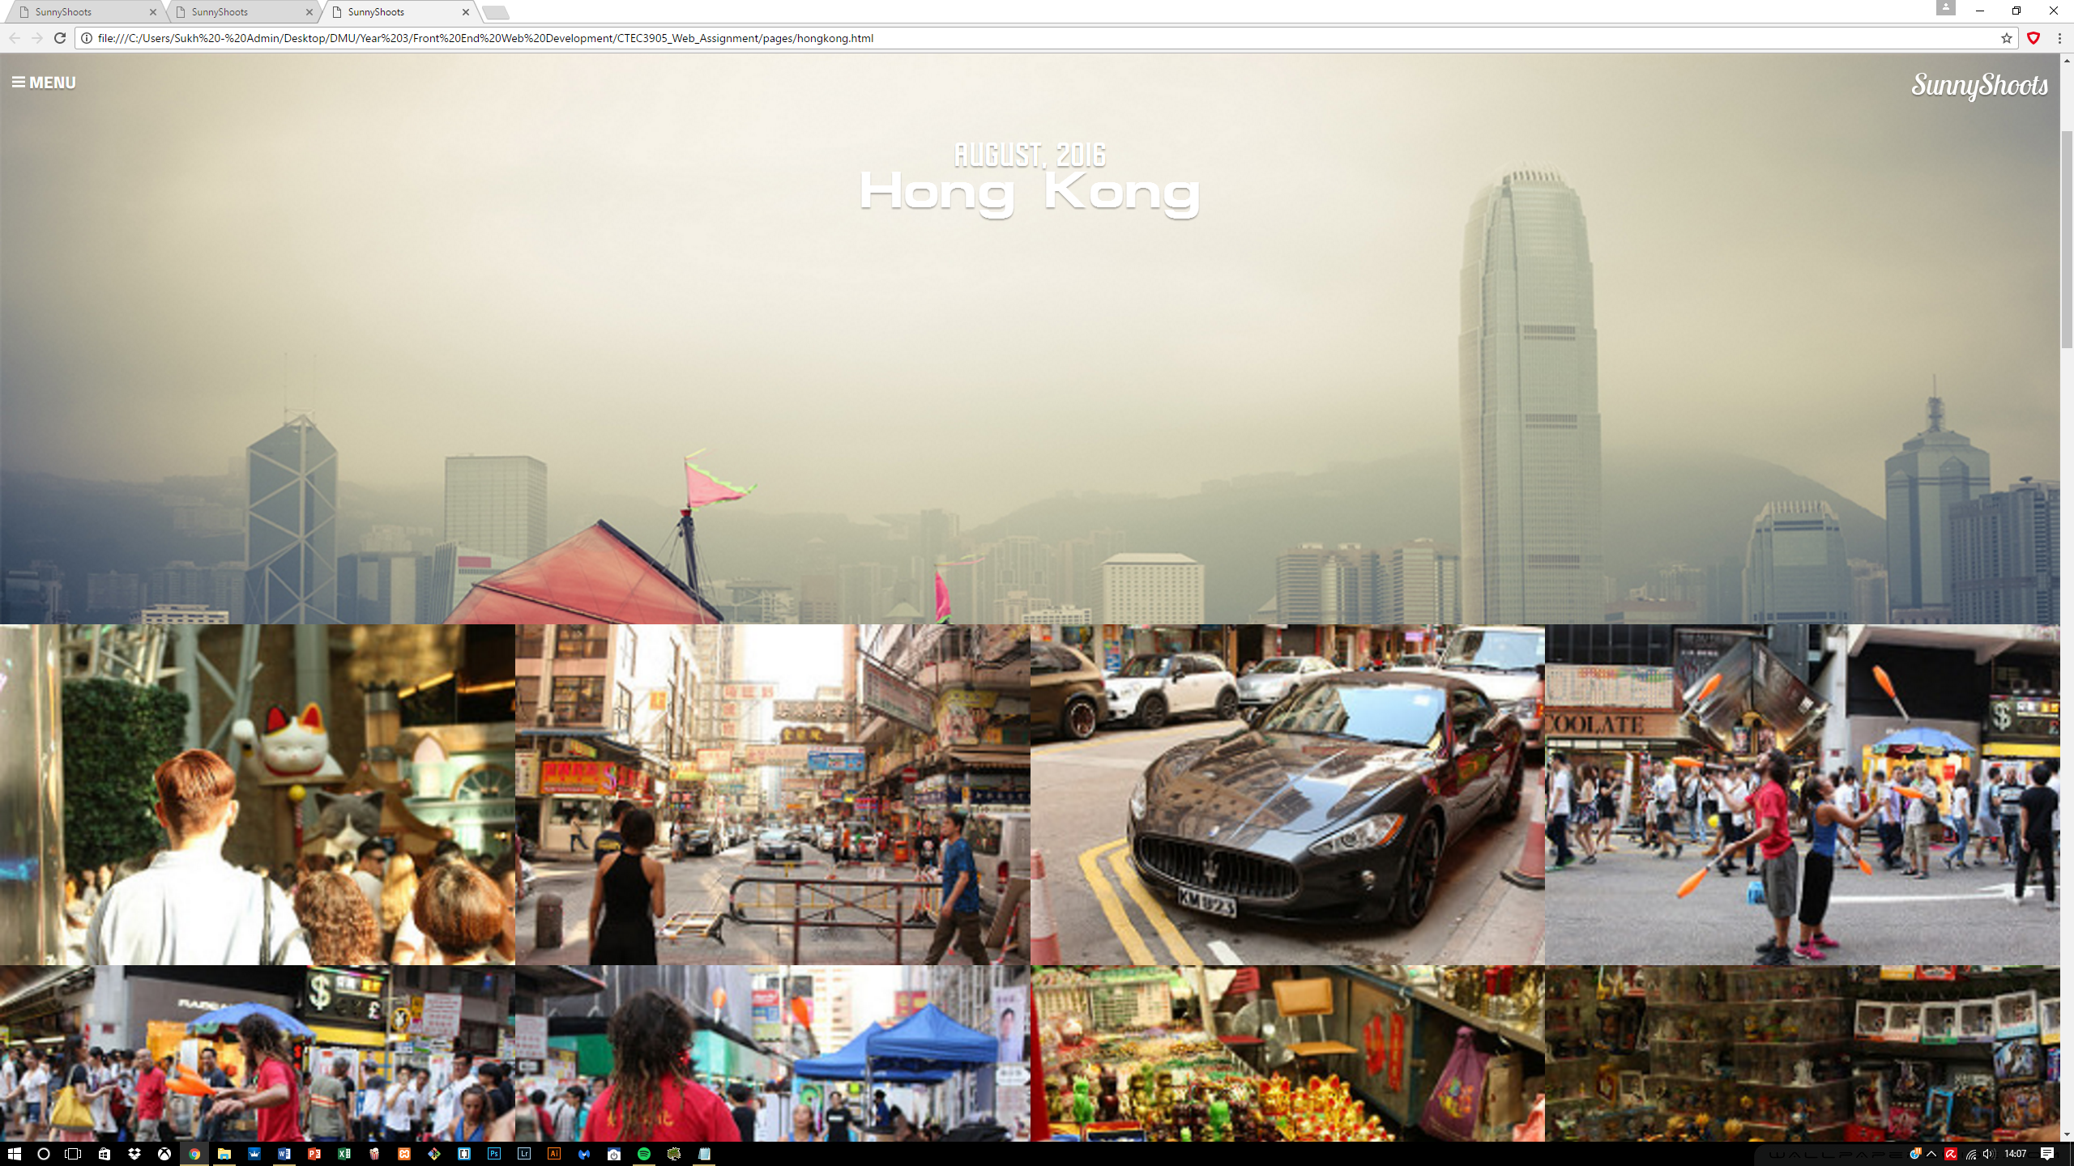

Now I need to focus on completing the responsive side of this site, so that everything conforms to a standard.

Overall the styling did not come across as hard but it really depended on the HTML structure if any progress is needed to be made and with the help of flexbox I was able to create the images in a wrapped format so they all align on the left as more images are added.

**Menu creation**

The menu took a while to do due to the complexity involved and also because of developing it in an entirely new way using radio buttons. It required inputs and labels learnt from one of the University web development lab sessions and in that it suggests using radio buttons as the navigation panel. These radio buttons are hidden and controlled by the labels which act as buttons and in return we get what’s shown below.

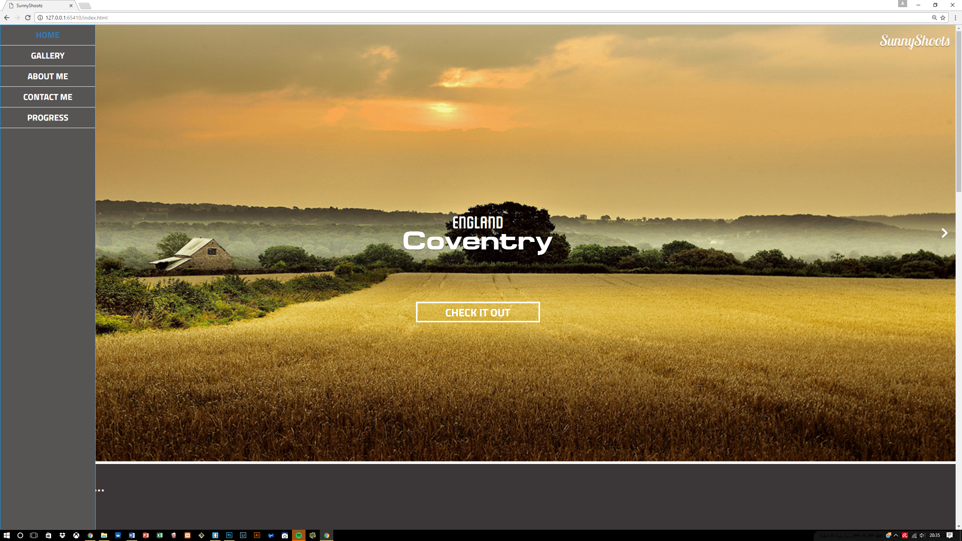

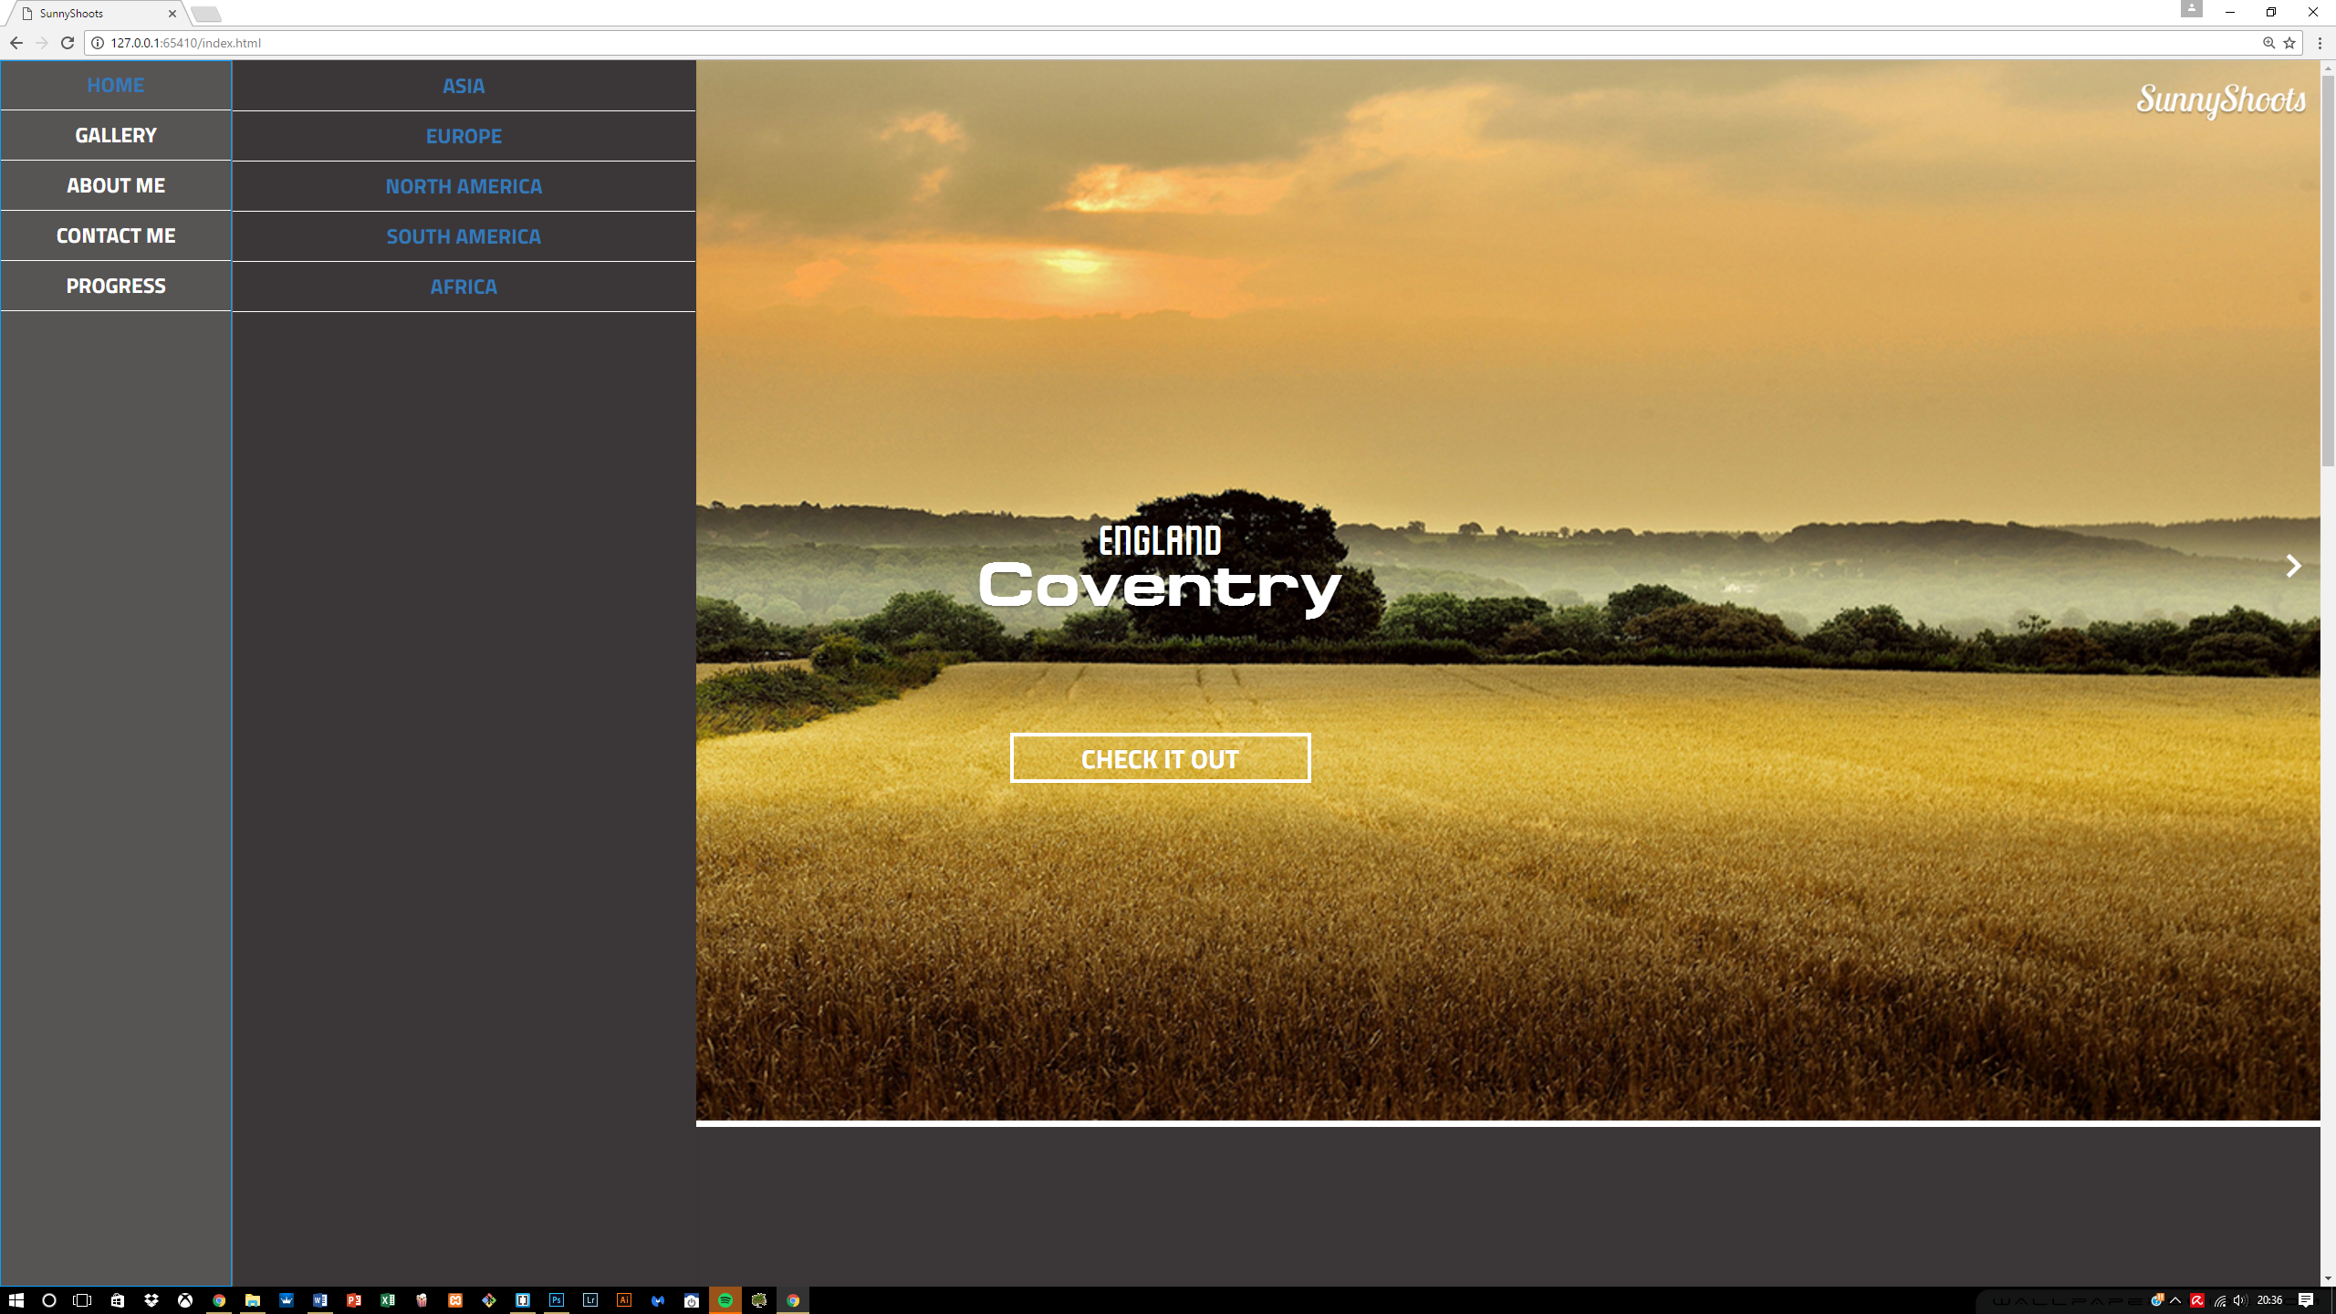

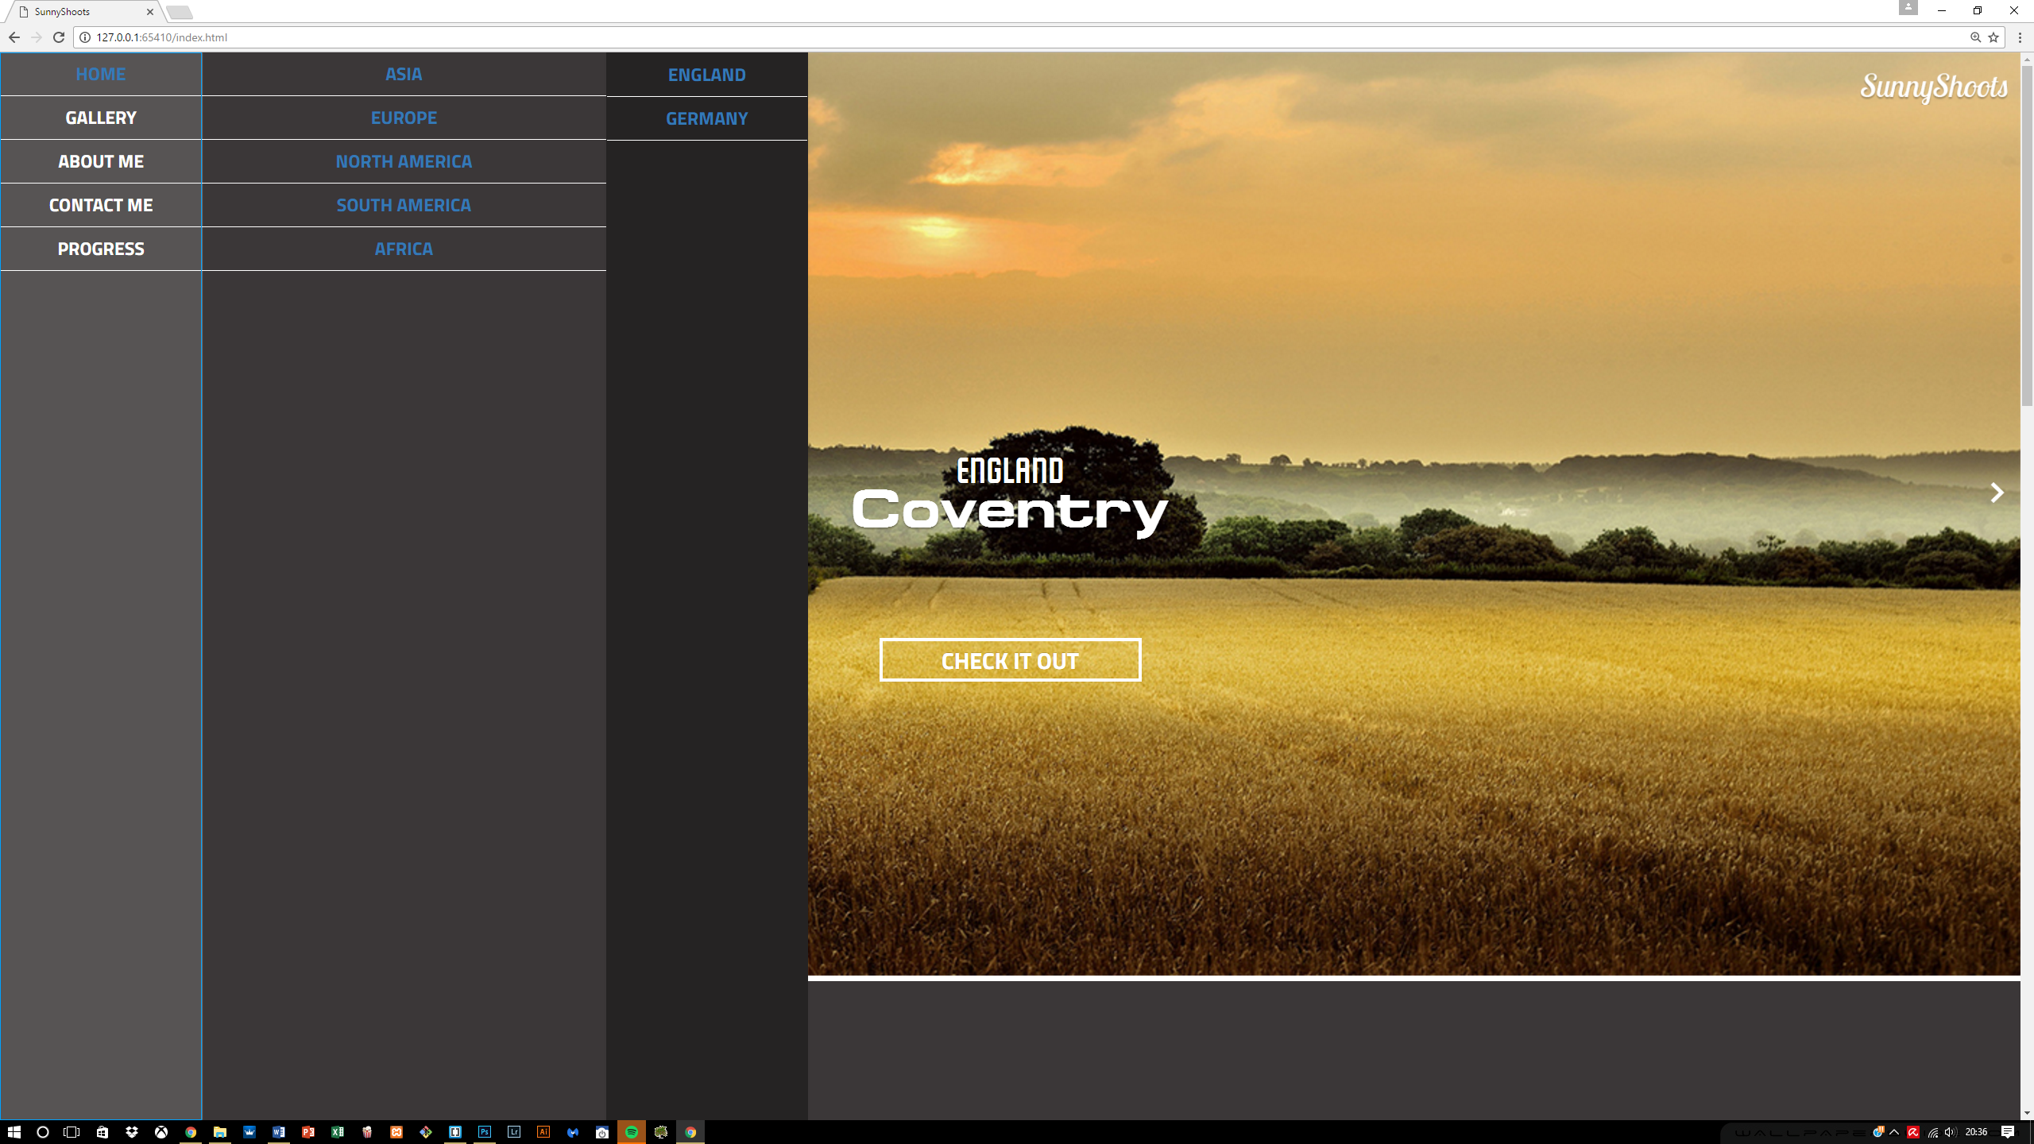

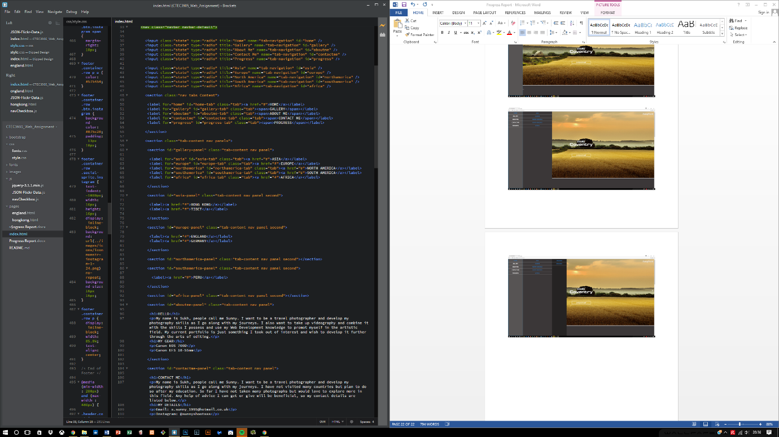

**Responsive side of the site**

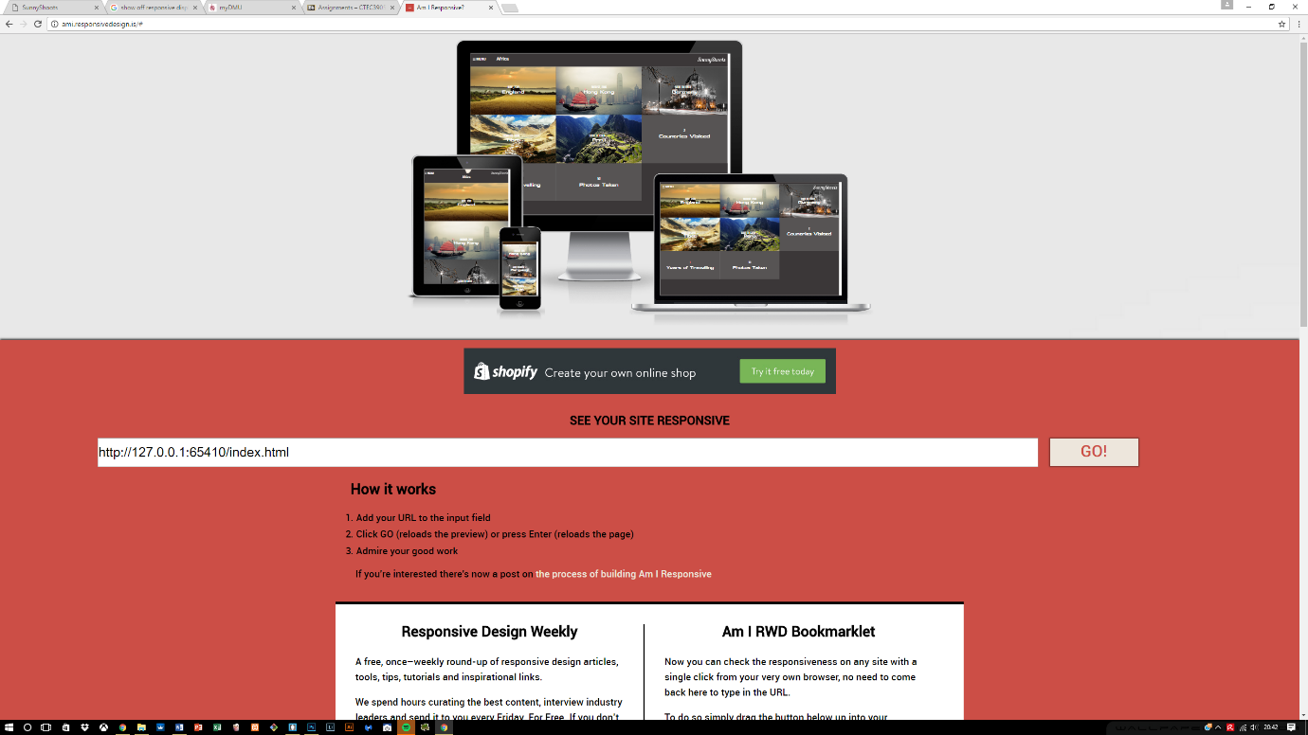After the menu creation, I started working on the responsive aspect of the website which required 4 breakpoints altogether, each of which ranges from the small to the largest device and works perfectly well.

**Info content moved from Albums content**

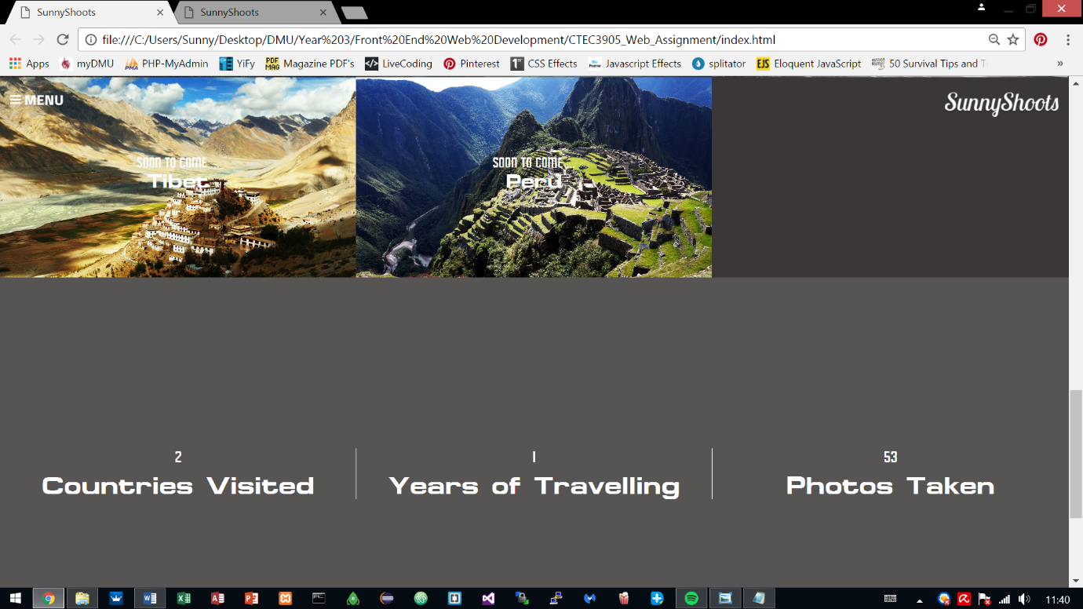The previous information from the Albums content has been moved into its own section which complies with one of the rules in PARC which is contrast and now looks much better when it is separated.

**Navigation Bar responsive**

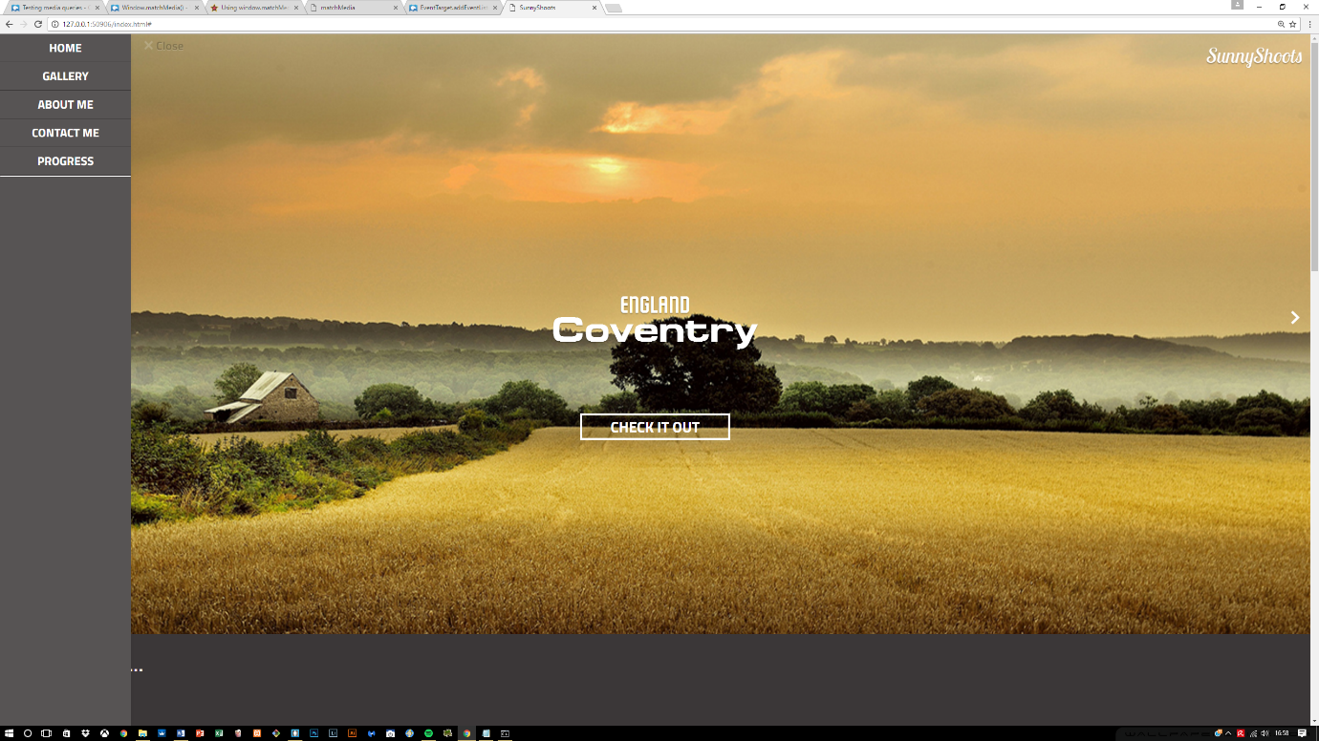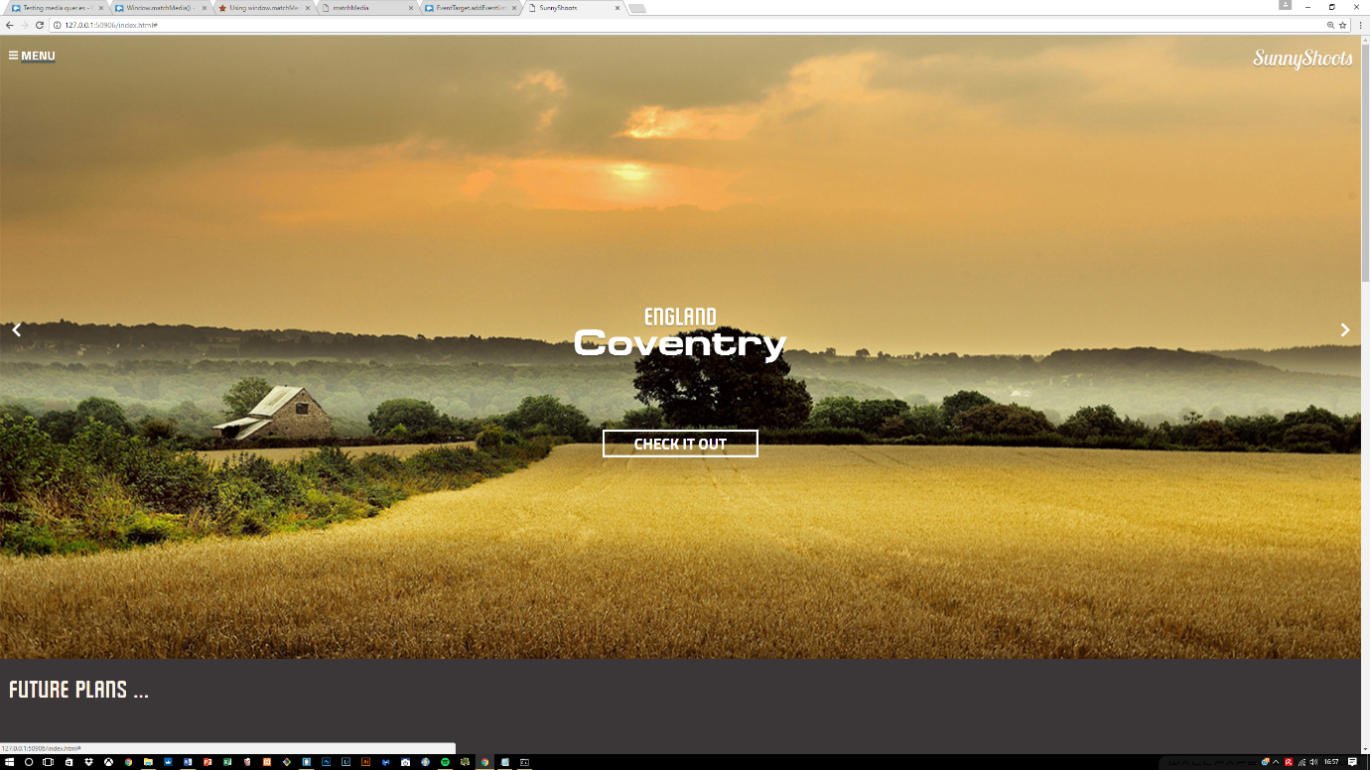Previous navigation bar had to be hidden using the CSS declared for Bootstrap, known as “hidden”. With this the navigation bar was hidden but now within the new changes, using the help of JavaScript it allows the navigation bar to appear and be closed using the Menu and Close buttons.

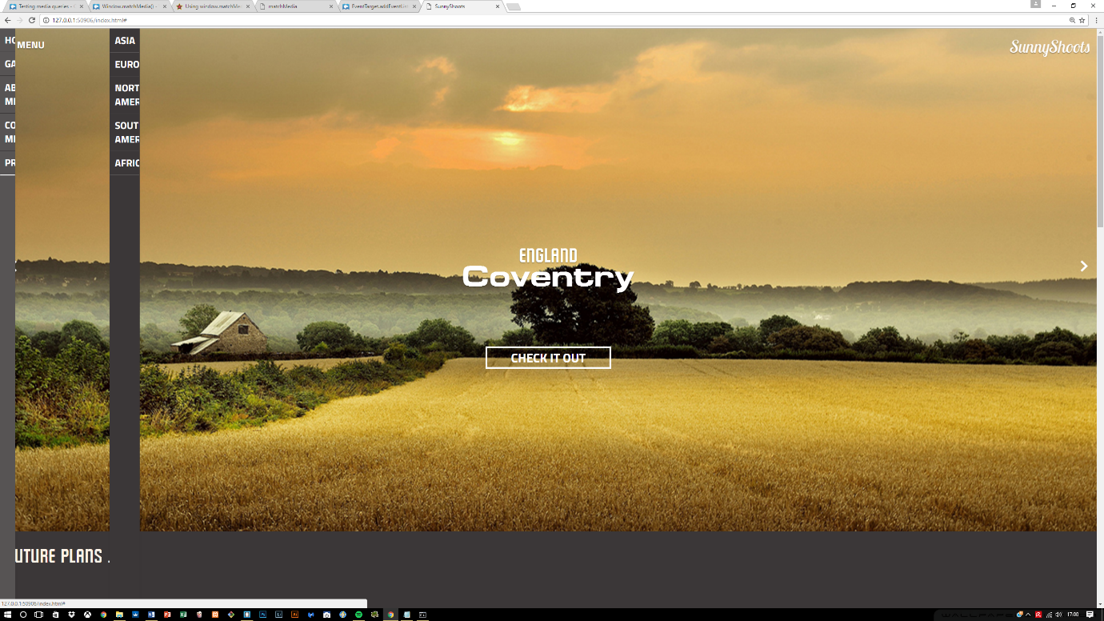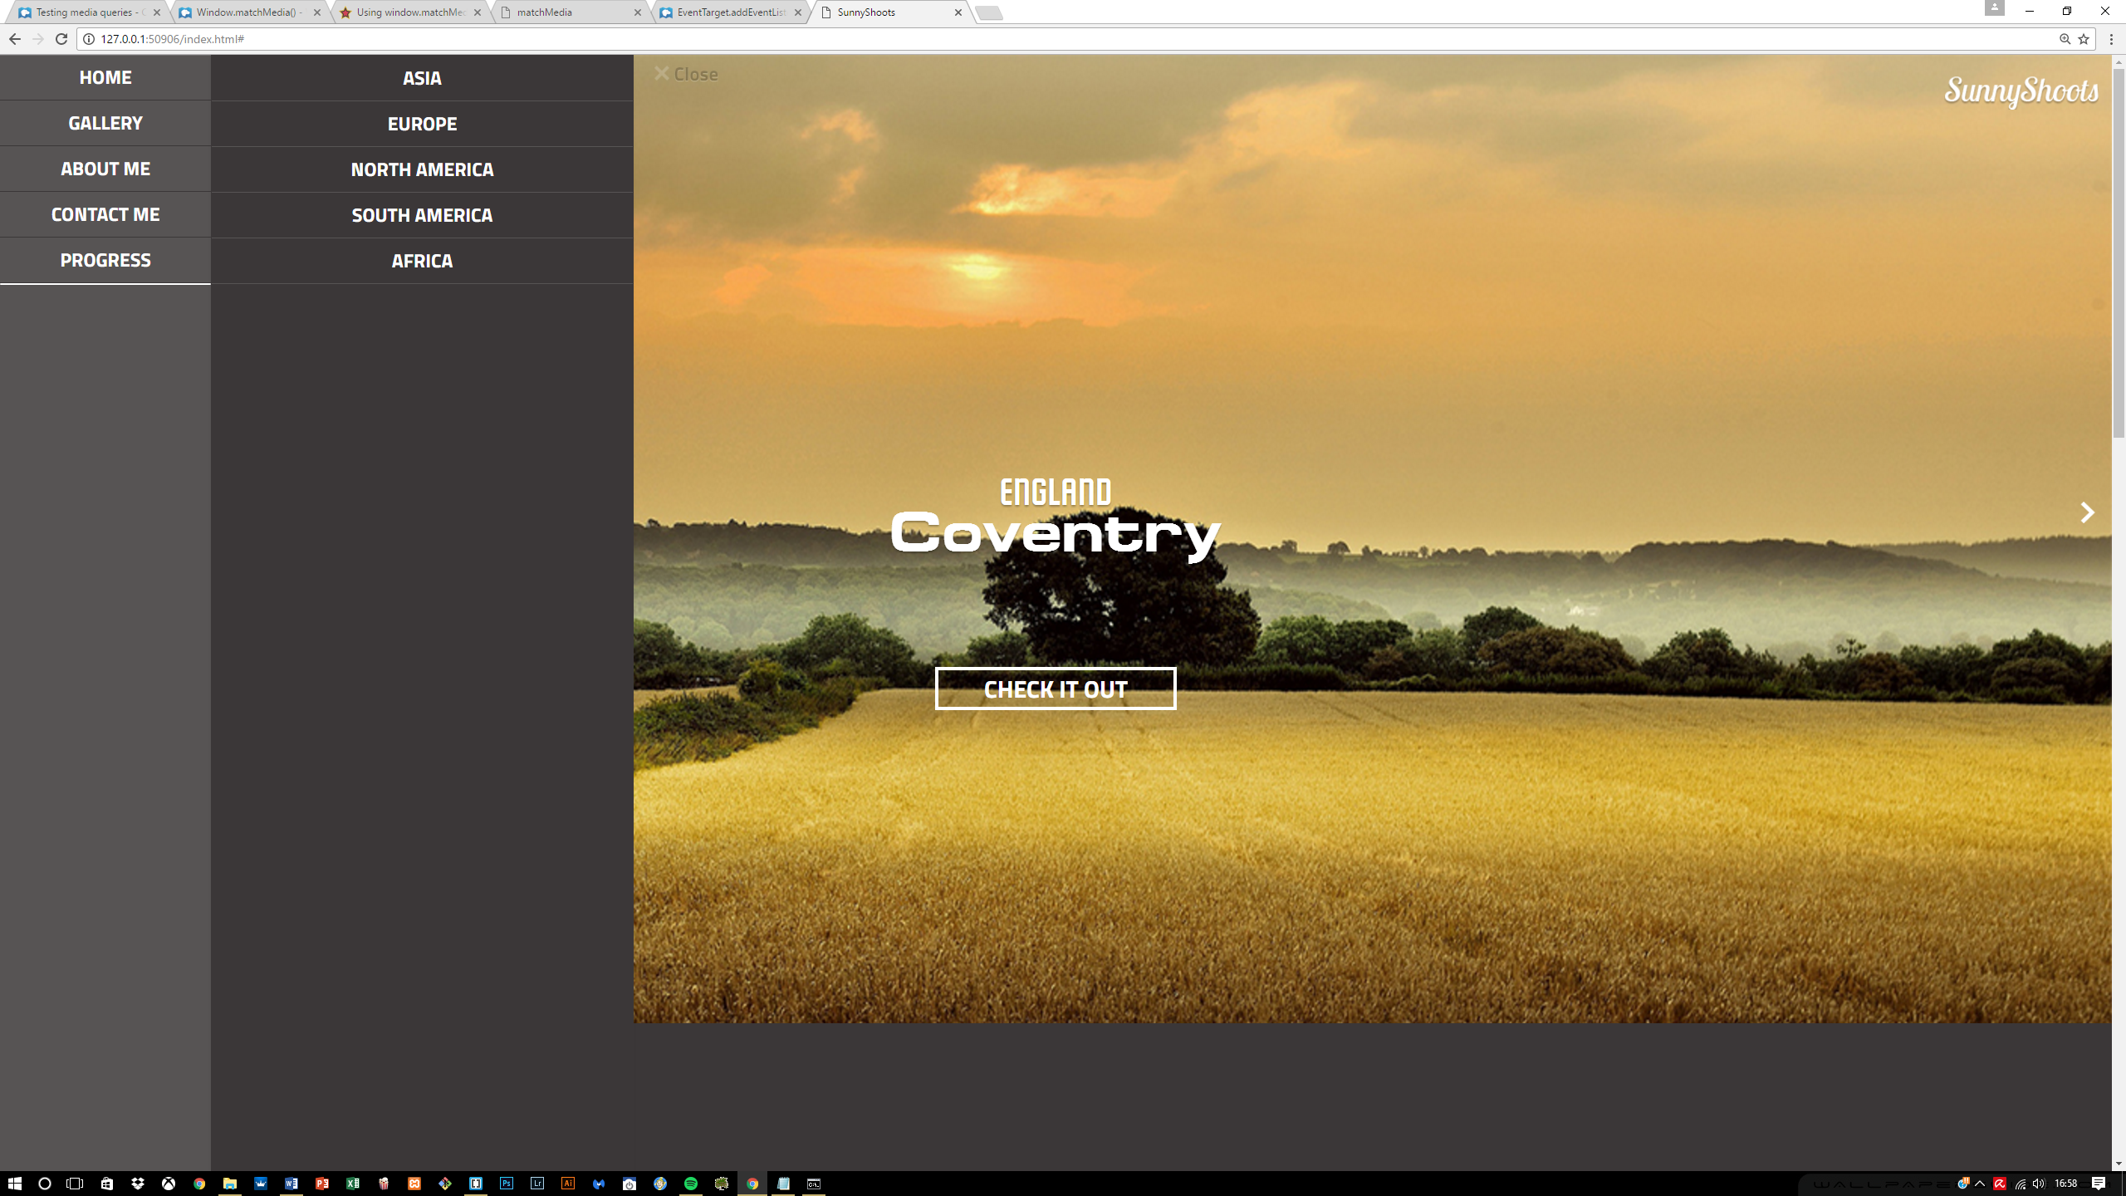

When the close button is clicked, the width is removed within JavaScript of the navigation bar and the transition that is set at 0.5s allows this transitioning to occur creating a nice effect.

The entire navigation bar is done using radio buttons and labels which have been designed within CSS to hide any unwanted properties and allowing thus to maintain the elegancy of the navigation bar. This approach is utilized for testing whether menu can still perform the same way as using anchor tags or unordered lists. The problem with this approach I find is that, it takes a long time to build a menu bar with this approach and a lot of time and configuration that can be easily done with using other tags, is utilized.

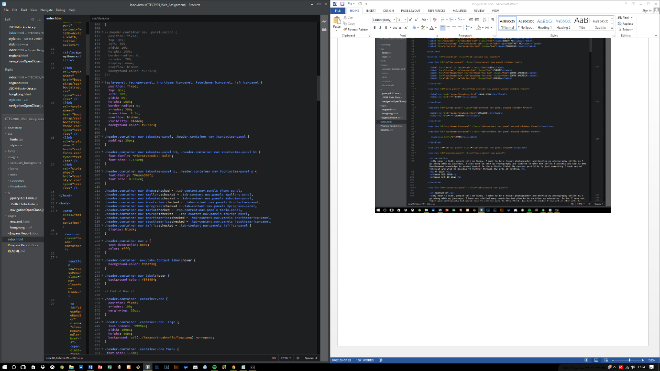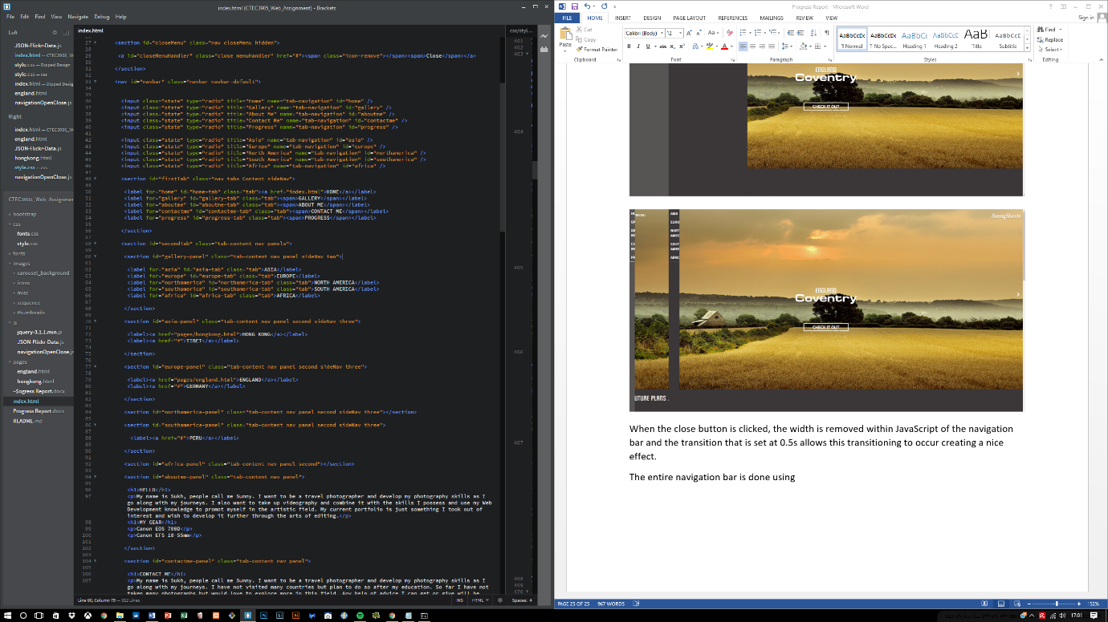The code for this is shown below:

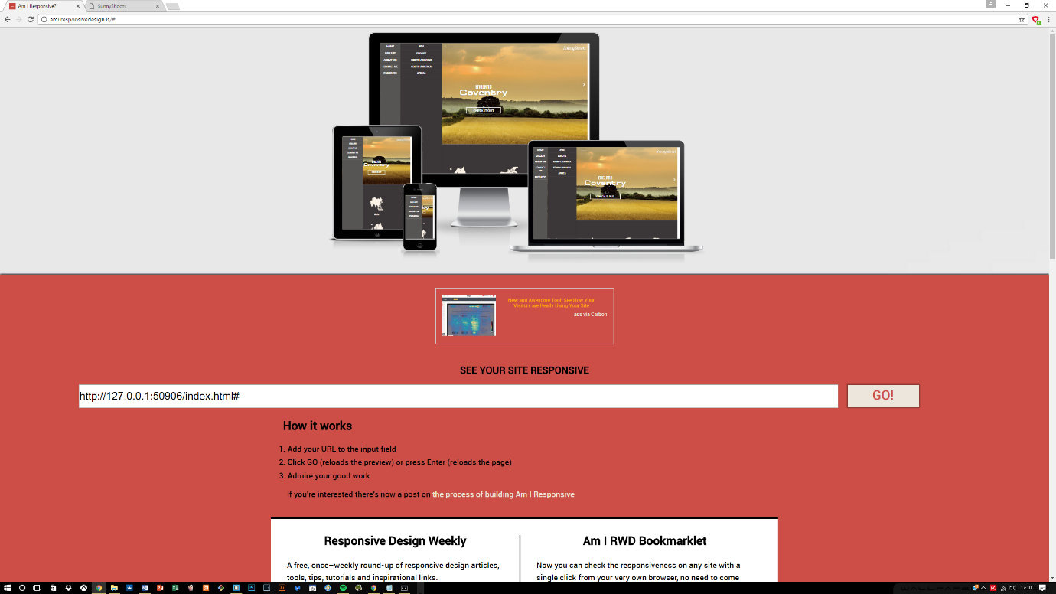At first it seemed impossible to be able to create an interactive menu using labels and radio buttons because of the configuration that needs to go in to it but with the help of JavaScript, it was easy to maintain the responsive aspect of the menu. JavaScript also provides ***window.matchMedia()*** function and with this it was easier to listen for changes within the screen size and helped adopting to the screen sizes.

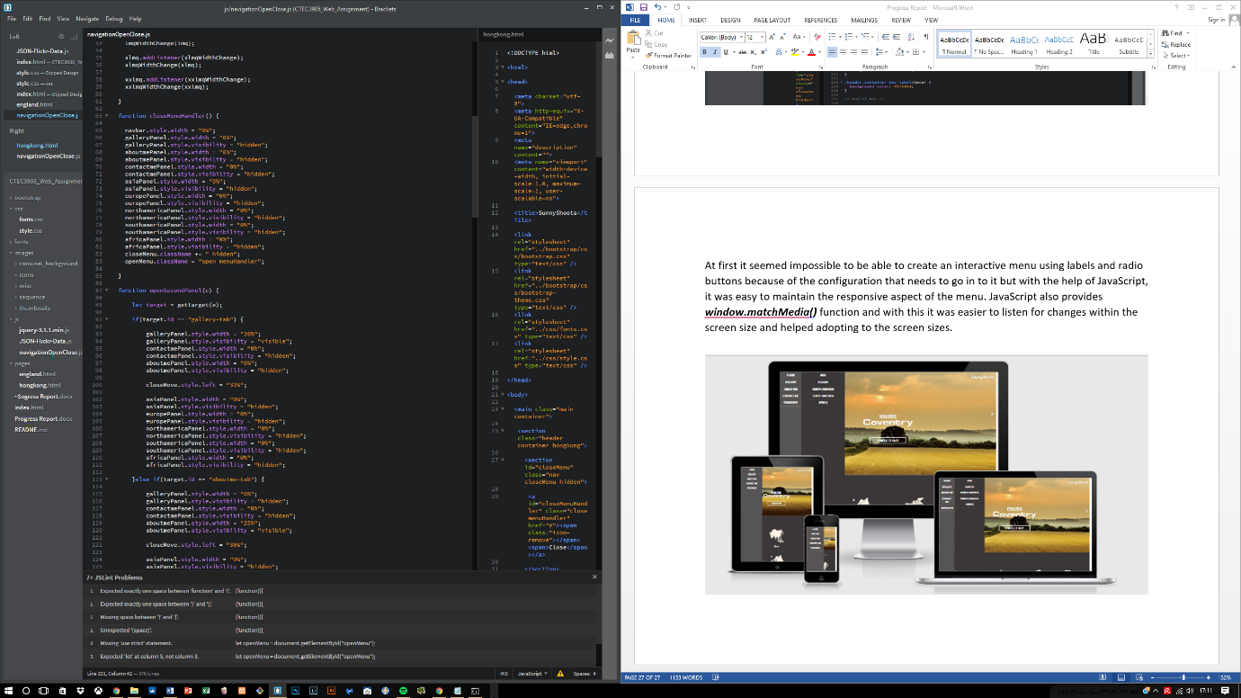

**Navigation bar finished**

Previous navigation bar dealt with many changes and they included mostly features created in JavaScript. The navigation bar required CSS to hide and show the bar and it did not adjust to different screen sizes, however the new changes and the final changes that have been done to it are of the following:

* No use of “hidden” within the CSS to hide the navigation bar
* Uses menu and close buttons to open and close navigation bar
* With the help of **window.matchMedia(),** it now performs much better when resized, using 5 different media query listeners ranging from the smallest to largest size.
* 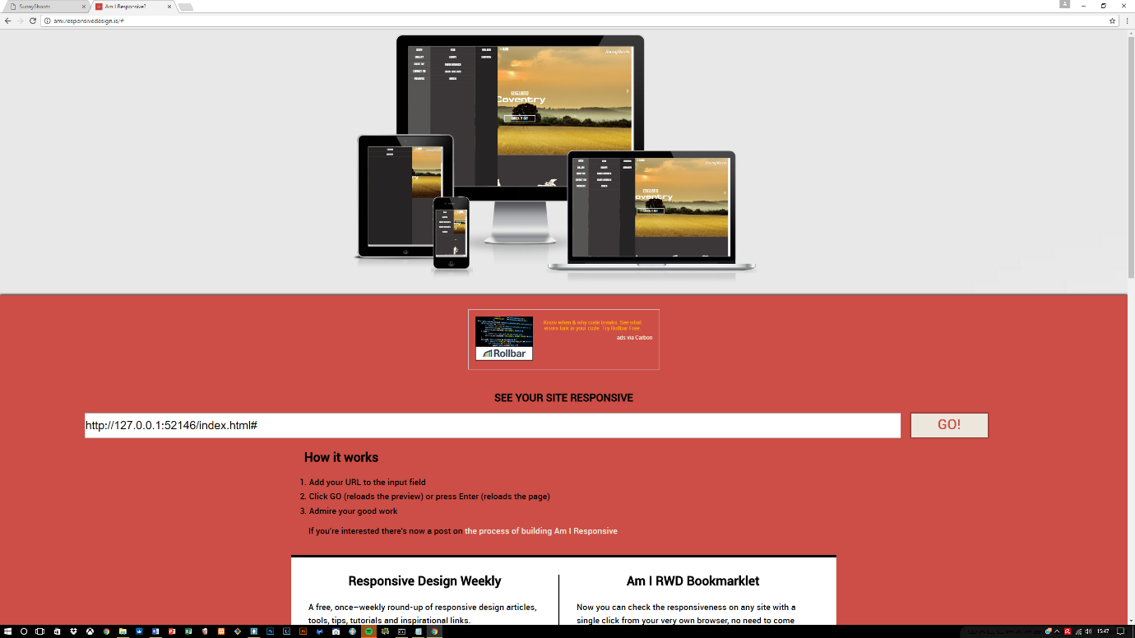Each screen size has a different style of navigation, some are 3 tabbed on larger screens and on smaller screens its 1 tab.

**Image hover effect**

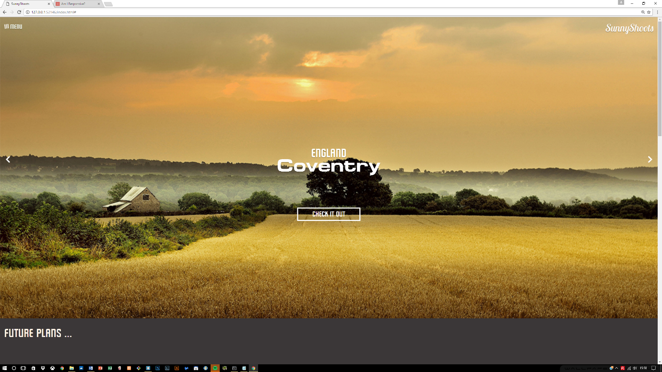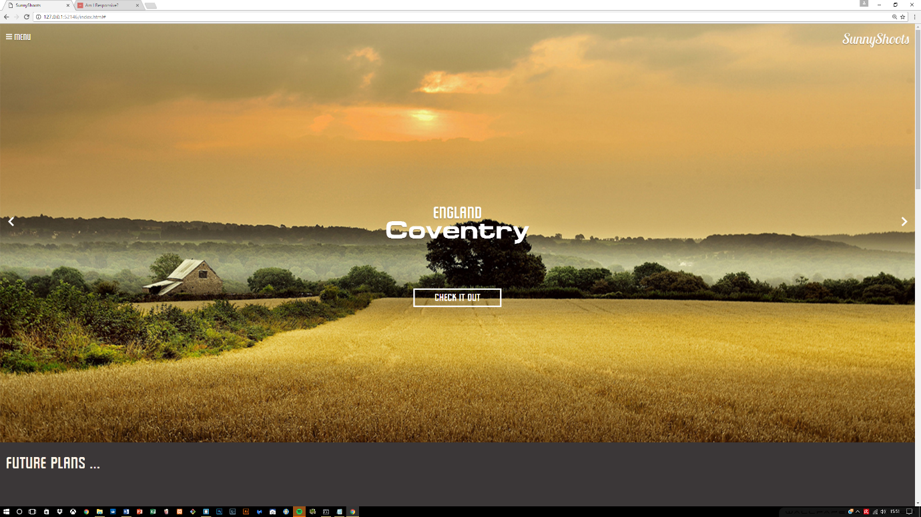With the advancement of CSS3, it provided so many benefits when it came to styling the features on the website. One of the features included hovering over the menu label and the hamburger sign transitioning in a 360 degree angle.

Other areas where this was applied included the countries section, where different countries are being presented. On this a hover effect is applied so that when hovering over the image, the image produces an overlay which is shown below:

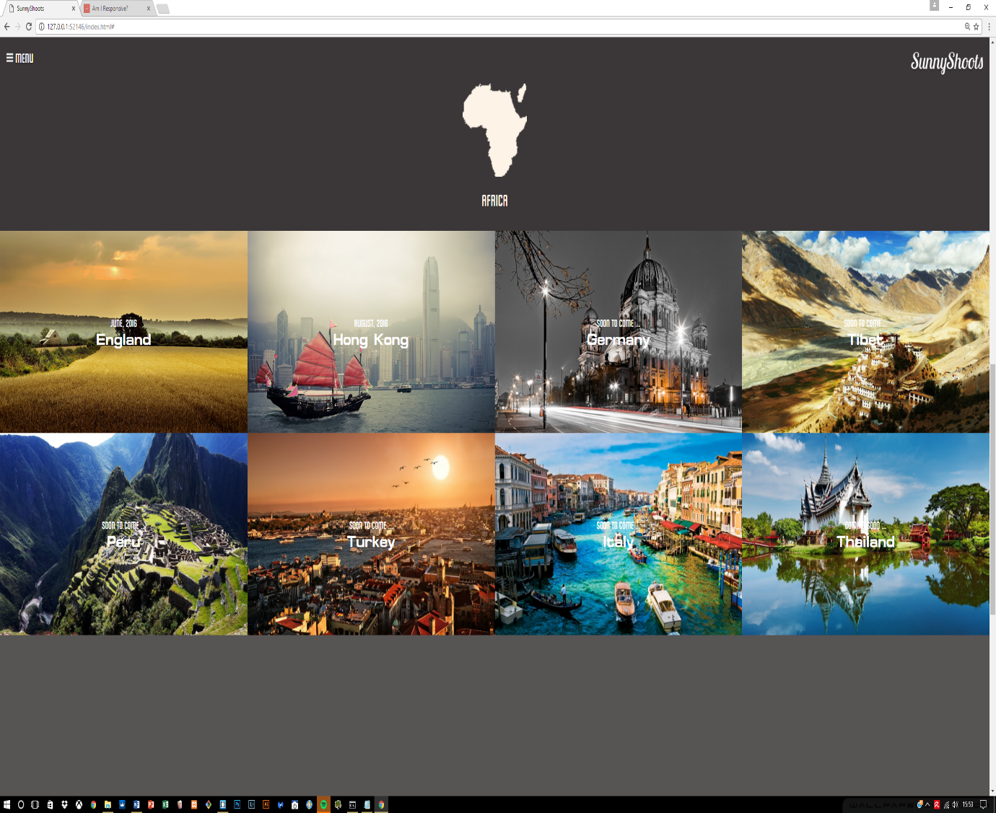

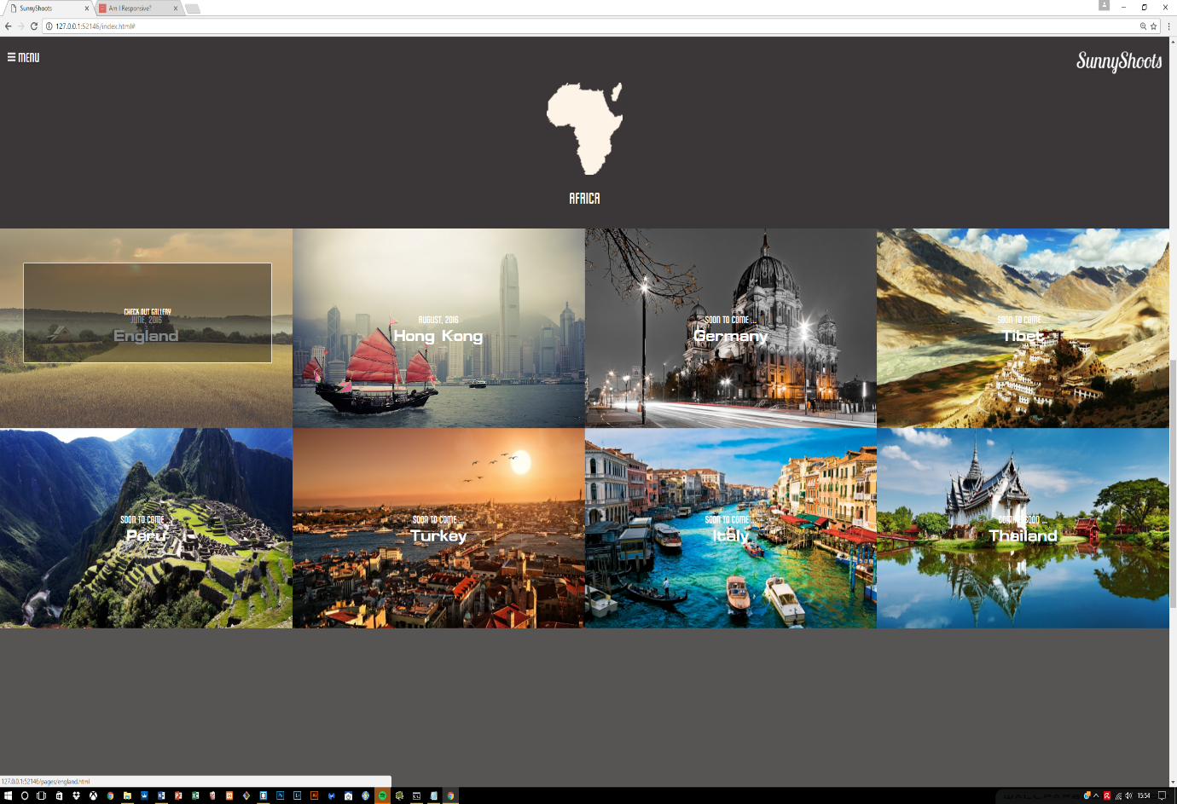

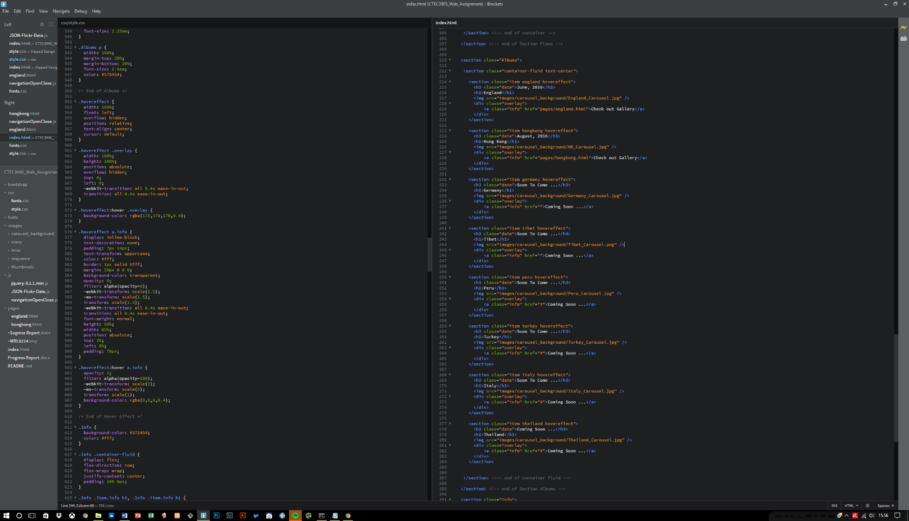This was achieved using HTML classes and CSS to contain and hide the information until required using a hover. The CSS was mainly utilised for decorating the overlay effect. The code is provided below: